Market Functionality Index — Gaza
Assessment period: 2026-07-01 to 2026-07-31
Methodology: Scores and tables follow databridge-current. Summaries are unweighted descriptions of assessed markets and are not population-representative country estimates.

Executive summary
The unweighted regional mean overall Market Functionality Index (MFI) score for the Gaza Strip was 5.98/10. The priority dimensions identified for this assessment were Service, Price, and Infrastructure. The unweighted regional mean Service score for the Gaza Strip was 4.26/10, representing the most constrained dimension in the assessment. The unweighted regional mean Price score for the Gaza Strip was 6.14/10, and the unweighted regional mean Infrastructure score for the Gaza Strip was 6.69/10.
Among the selected markets, An Nasser recorded the lowest overall MFI at 4.30/10, with severe limitations documented in Price (1.67/10), Availability (2.50/10), and Infrastructure (3.57/10). Az Zawayda achieved an overall MFI of 4.48/10, driven by pronounced constraints in Assortment (2.00/10) and Service (3.33/10). Other key assessed markets, including Al Bureij Camp (5.22/10) and Ash Sheikh 'Ijleen (5.23/10), consistently demonstrated substantial constraints in the priority dimensions.
Within the Service dimension, checkout and shopping capabilities were systemically limited. Assessed markets recorded critically low unweighted mean rates for visible price tags (0.79/10) and automatic itemized receipts (0.63/10). Within the Price dimension, instability was prevalent across categories; assessed markets recorded low unweighted mean stability rates for Other food (2.72/10), Cereal food (3.02/10), and Non-food items (3.14/10). High unweighted mean price instability rates were specifically documented for Fruits and vegetables, Shelter, and Meat, fish and eggs.
The Infrastructure dimension reflected poor physical market conditions. Assessed markets recorded extremely low scores for Walkways and emergency exits (1.48/10) and physical Shelter (1.48/10). This coincides with external reporting from July 2026 detailing extensive infrastructure damage across the Gaza Strip due to ongoing conflict [S1, S2, S5]. Despite these conditions, Food Quality remained strong, and the unweighted regional mean Access & Protection score for the Gaza Strip was 9.85/10 within the specific operational bounds of the surveyed market spaces.
The assessment measures conditions strictly at the specific market site during the exact time of the survey. The evidence does not establish affordability, purchasing power, inflation, or beneficiary outcomes, nor does it infer overall programme feasibility from MFI evidence. All summaries are unweighted descriptions of included assessed markets and are not population-representative country estimates. Item eligibility uses assessed-market coverage, and the processed data do not provide reliable item-specific trader denominators. Recommendations include continuous monitoring of price volatility, further verification of structural safety capabilities, and conducting feasibility assessments regarding retail service capacities.

Country context
In July 2026, the Gaza Strip remained an environment of extreme war risk [S1]. The government administration of Gaza was undergoing transition following the dissolution of Hamas’s Emergency Committee; however, the transfer of responsibility for civilian administration to the US-backed National Committee for the Administration of Gaza (NCAG) remained stalled [S1]. Despite a 20-point peace plan agreed upon in late 2025 and a recently announced agreement regarding the potential disarmament of Hamas, active military operations and strikes by Israeli forces continued throughout the month [S1, S5].
Humanitarian monitors and UN reports documented that restrictions on vital aid deliveries and commercial goods through border crossings remained in place [S1]. The ongoing conflict coincided with widespread infrastructure damage and the absence of functioning administrative institutions across the territory [S2, S5]. While Palestinian legislative elections were nominally scheduled for November 2026 by presidential decree, severe operational and security barriers constrained their viability in Gaza [S2].
The external context provides a backdrop for the assessment period but does not establish local causality for individual market metrics. The assessment evidence does not predict future logistical continuity under changing security conditions. Further monitoring of regional conflict developments and continuous feasibility assessment for market access are requested. All summaries are unweighted descriptions of included assessed markets and are not population-representative country estimates.

Dimension scores across assessed markets
Dimension | Mean /10 | Markets
Assortment | 7.78 | 27
Availability | 9.14 | 27
Price | 6.14 | 27
Resilience | 7.92 | 27
Competition | 8.49 | 27
Infrastructure | 6.69 | 27
Service | 4.26 | 27
Food Quality | 9.44 | 27
Access & Protection | 9.85 | 27
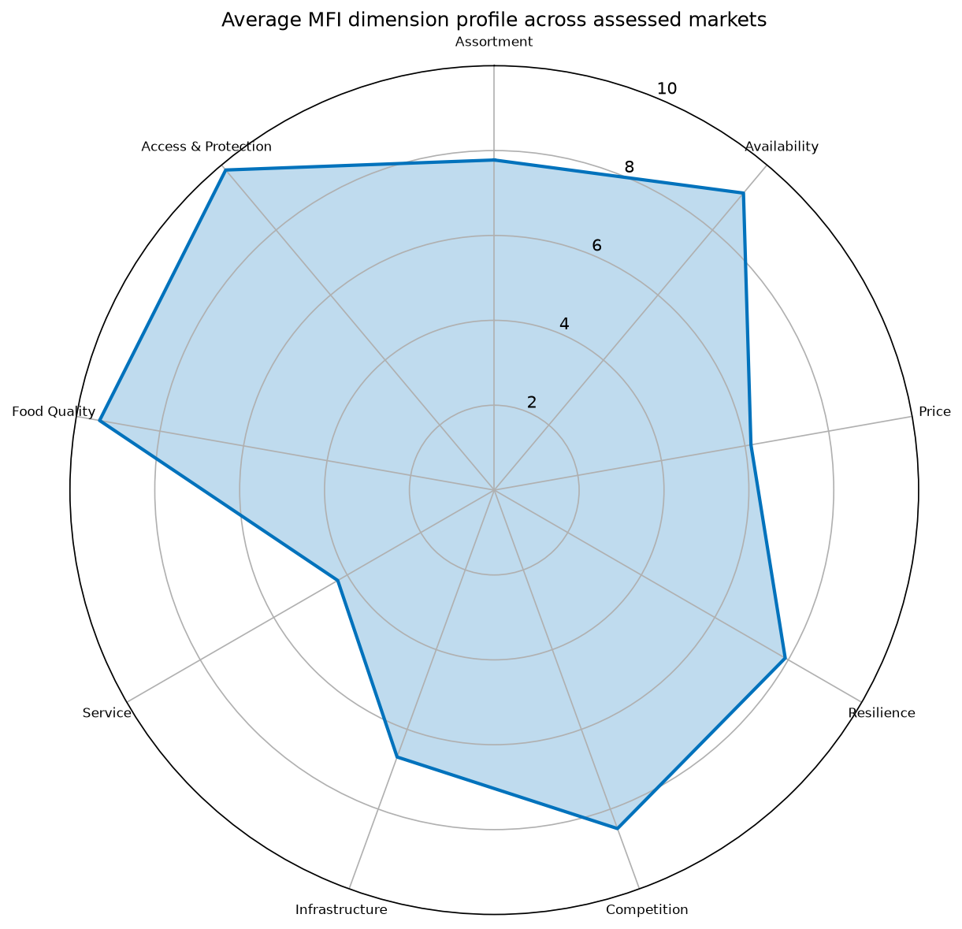
mfi radar
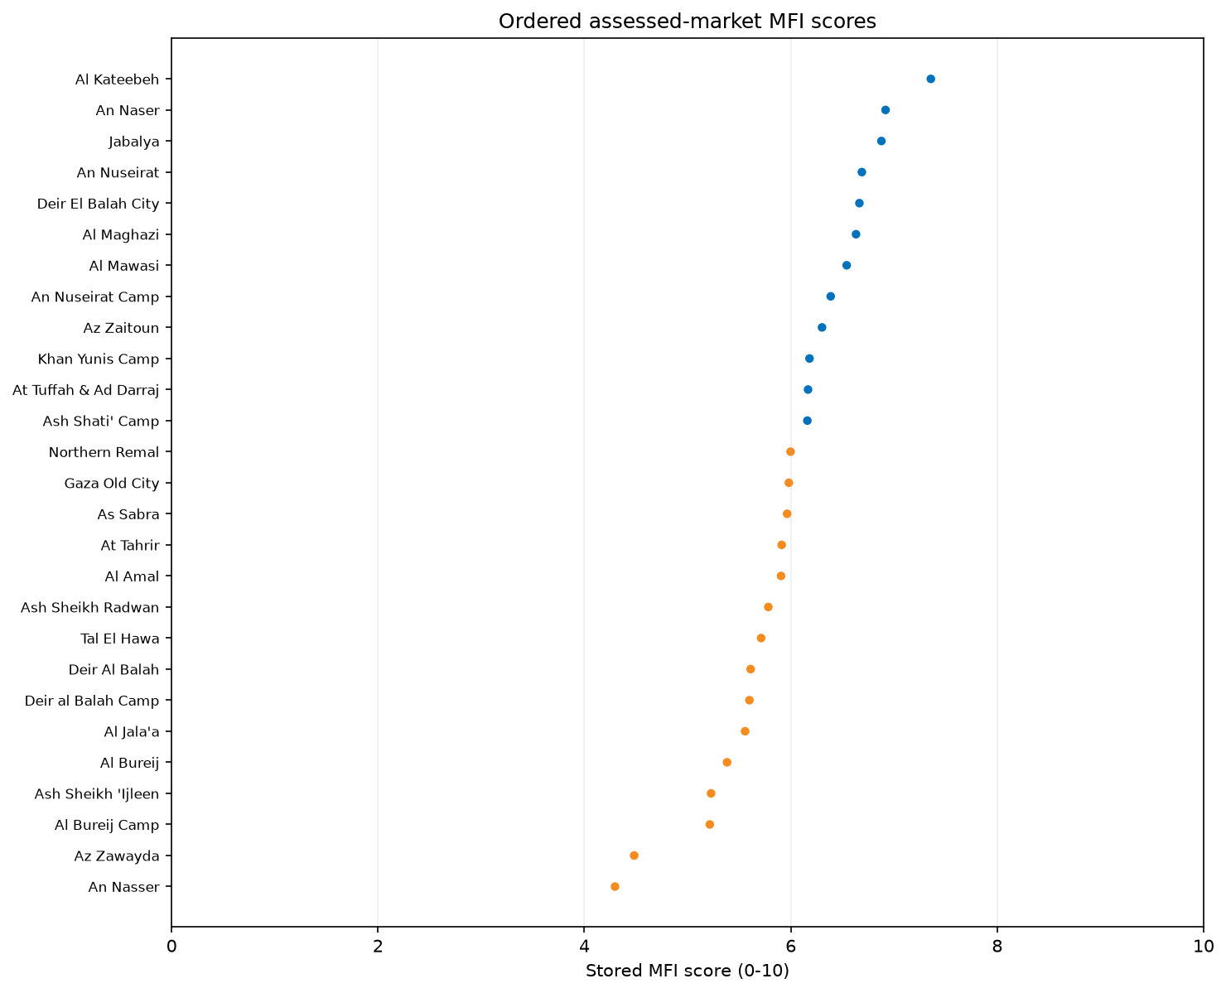
market score ranking
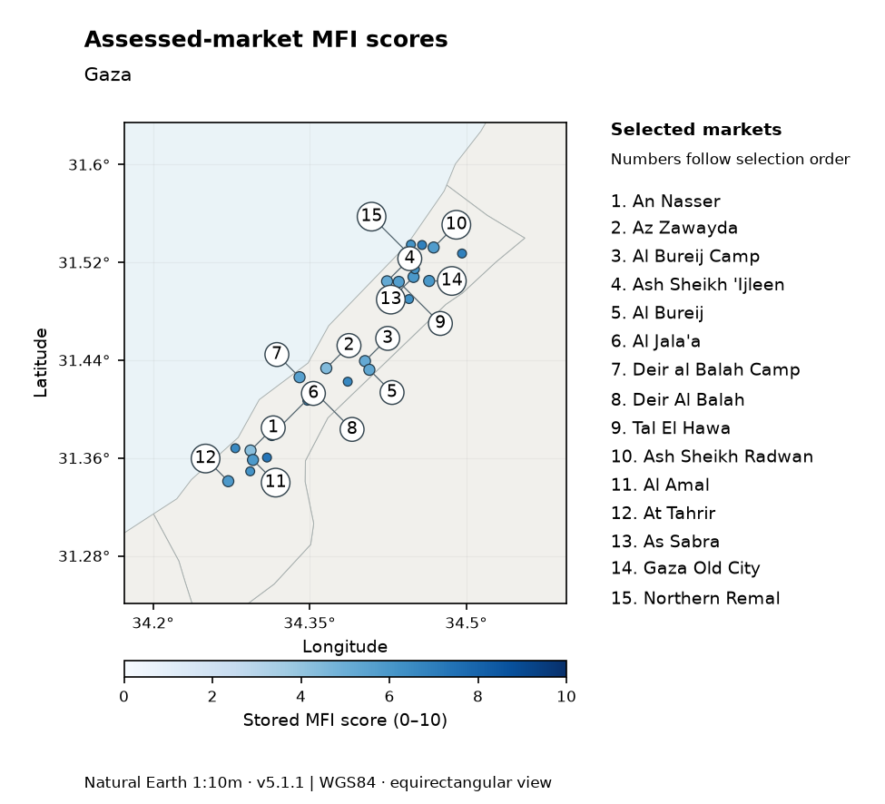
Stored assessed-market MFI scores in the assessed area. Colours show scores on the 0–10 scale; numbered callouts identify selected markets in selection order and match the side legend. Coordinates available for 27/27 assessed markets. Country outline could not be identified; background follows market coordinates.
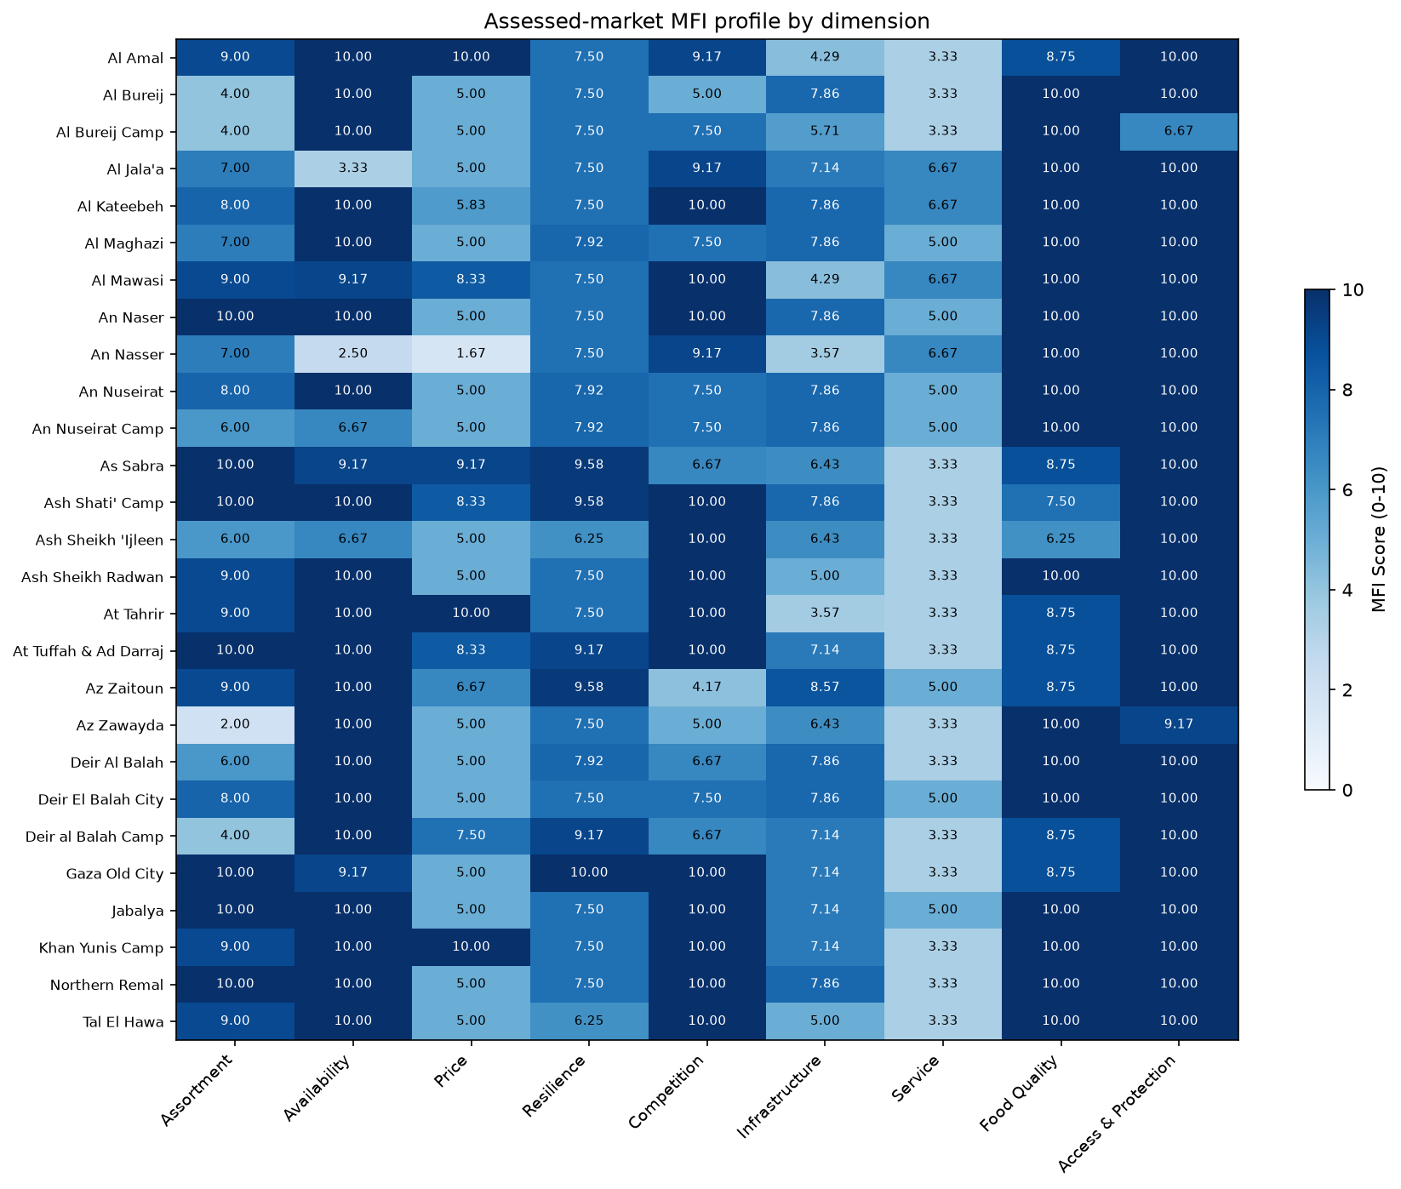
overview table

MFI dimensions

Assortment
The unweighted regional mean Assortment score for the Gaza Strip was 7.78/10. 20 of 27 assessed markets scored at or below the median of 9.00/10 for Assortment. 20 of 27 assessed markets scored below 10/10, 13 scored below 9/10, 10 scored below 8/10, and 7 scored below 7/10. The distribution of scores ranged from a minimum of 2.0 to a maximum of 10.0. The overall dimension reflected a score of 5.31/10 for the Assortment depth subsection and 8.84/10 for the Assortment breadth subsection.
Within the Assortment depth subsection, the SKU depth items operate as descriptive metrics rather than normative scores. Assessed markets recorded an unweighted mean rate of 4.07/10 for the SKU depth of 1-50. Assessed markets recorded an unweighted mean rate of 3.33/10 for the SKU depth of 201-1,000. Assessed markets recorded an unweighted mean rate of 1.48/10 for the SKU depth of more than 1,000. Finally, assessed markets recorded an unweighted mean rate of 1.11/10 for the SKU depth of 51-200.
Within the Assortment breadth subsection, multiple category drivers achieved perfect scores. Assessed markets recorded an unweighted mean rate of 10.00/10 for Cereal food, Other food, and WASH items. Assessed markets also recorded an unweighted mean rate of 9.63/10 for Household items, 8.89/10 for Health items, 8.15/10 for Communication items, and 8.15/10 for Education items. The Shelter category recorded a comparatively lower breadth rate, with assessed markets recording an unweighted mean rate of 7.04/10.
Item-level drivers revealed further disparities within these categories. Cereal assortment breadth was restricted for specific staples; assessed markets recorded an unweighted mean rate of 1.06/10 for Bread, 1.77/10 for Barley, 3.98/10 for Wheat, and 4.71/10 for Flour. Conversely, assessed markets recorded high availability rates for Rice (9.17/10) and Pasta (8.60/10). Among Other food items, breadth was restricted; assessed markets recorded an unweighted mean rate of 3.26/10 for Milk and dairy products, 3.34/10 for Meat, fish and eggs, 3.50/10 for Fruits and vegetables, 4.19/10 for Herbs, condiments and spices, and 4.87/10 for Oils and fats.
External context from July 2026 detailed that restrictions on vital aid deliveries and commercial goods through border crossings remained in place, occurring alongside the expansion of an Israeli-imposed buffer zone [S1]. Furthermore, extensive infrastructure damage and ongoing military activity were cited as persistent regional challenges [S2]. These factors coincided with the assortment depth values and the breadth of fresh items and specific cereals documented in the assessment.
The assessment evidence does not establish affordability, purchasing power, or consumer outcomes based on assortment metrics. Further verification and monitoring of the availability of specific essential items, particularly fresh produce and wheat flour, are requested. A known limitation is that all summaries are unweighted descriptions of included assessed markets and are not population-representative country estimates. Additionally, item eligibility uses assessed-market coverage, and the processed data do not provide reliable item-specific trader denominators, necessitating caution when interpreting item-level driver scores.
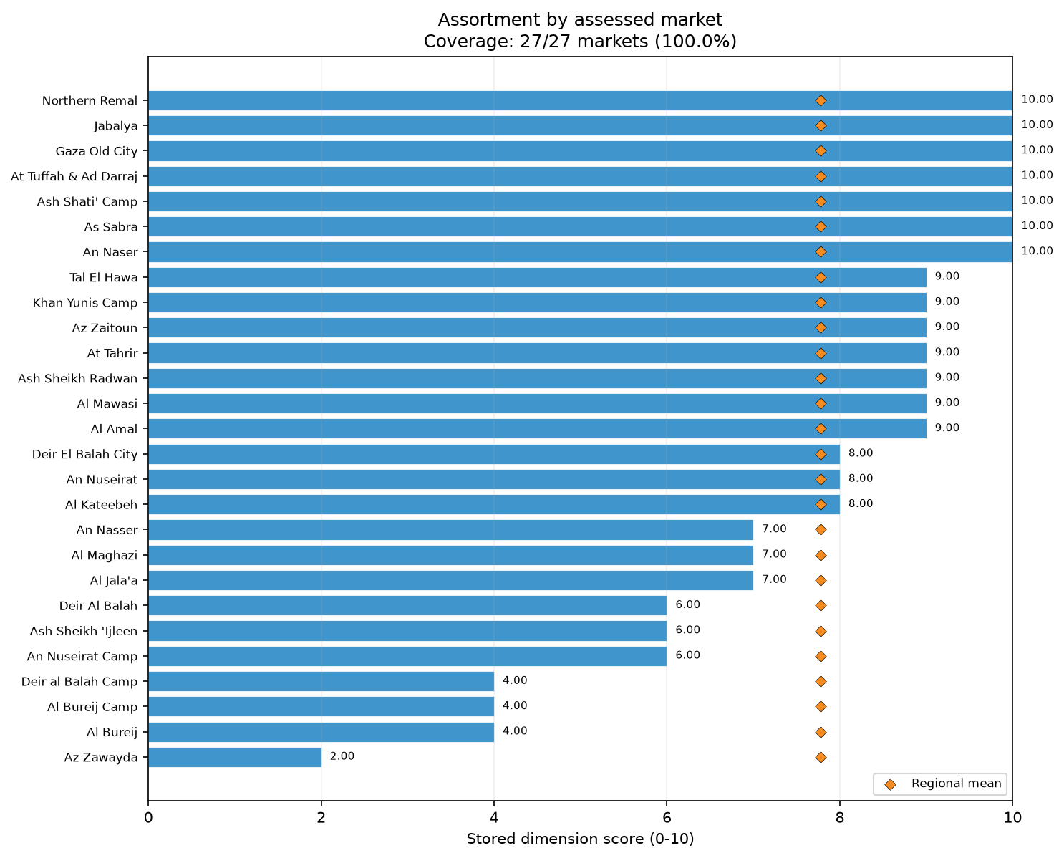
dim assortment bars

Availability
The unweighted regional mean Availability score for the Gaza Strip was 9.14/10. 27 of 27 assessed markets scored at or below the median of 10.00/10 for Availability. 7 of 27 assessed markets scored below 10/10, 4 scored below 9/10, 4 scored below 8/10, 4 scored below 7/10, and 2 scored below 6/10. The distribution of scores ranged from a minimum of 2.5 to a maximum of 10.0. The overall dimension comprised the Absence of scarcity subsection, which recorded a score of 9.20/10 across assessed markets, and the Absence of imminent runout subsection, which scored 9.07/10.
Within the Absence of runout subsection, assessed markets recorded an unweighted mean rate of 8.78/10 for Cereal food. Runout problem rates for specific Cereal items varied; assessed markets recorded unweighted mean runout problem rates of 2.50/10 for Barley and 1.30/10 for Flour. For Non-food items (NFI), assessed markets recorded an unweighted mean rate of 7.95/10 for Absence of runout, with Shelter items registering a runout problem rate of 1.54/10. The Other food category scored 6.89/10 for Absence of runout, with runout problem rates of 1.67/10 for Other non-cereal food among assessed markets. Assessed markets also recorded unweighted mean runout problem rates of 0.76/10 for Oils and fats, 0.69/10 for Legumes, nuts and seeds, and 0.65/10 for Milk and dairy products.
Within the Absence of scarcity subsection, assessed markets recorded an unweighted mean rate of 9.06/10 for Cereal food, 8.07/10 for Other food, and 6.49/10 for NFI. The component within NFI scarcity showing the highest scarcity problem rate was Shelter, where assessed markets recorded an unweighted mean rate of 3.72/10. Unweighted mean scarcity problem rates were also reported for Barley (2.50/10), Wheat (1.17/10), and Flour (1.07/10) within the assessed markets. Scarcity problem rates were additionally noted for Communication items (0.83/10) and Education items (0.56/10).
External reporting from July 2026 detailed ongoing conflict, military operations, and highly restricted aid deliveries through border crossings [S1, S2, S5]. The continued restrictions on humanitarian aid and commercial goods occurred alongside the scarcity and runout problem rates for specific NFI and food categories documented within the assessed markets during this period.
The evidence does not establish the causal mechanisms of individual item scarcities at the market level, nor does it infer overall programme feasibility, inflation, or purchasing power. Further verification and continuous monitoring of shelter and cereal availability across the Gaza Strip are requested. A notable limitation of this analysis is that all summaries are unweighted descriptions of included assessed markets and are not population-representative country estimates. Furthermore, item eligibility uses assessed-market coverage, and the processed data do not provide reliable item-specific trader denominators, requiring careful application of the findings when analyzing individual item patterns. The assessment evaluates availability purely through responses within the specific confines of the assessed market spaces.
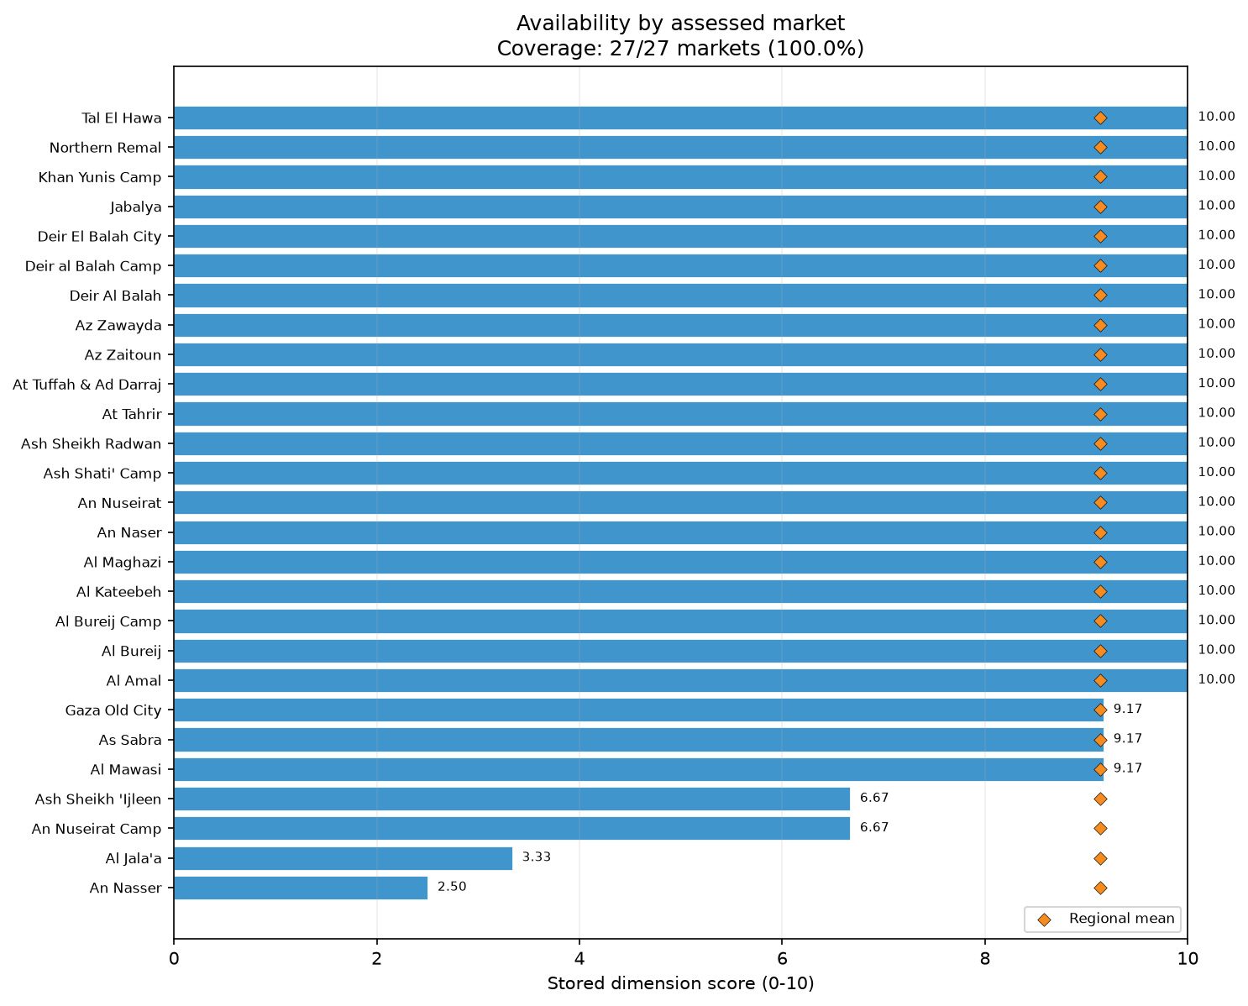
dim availability bars

Price
The unweighted regional mean Price score for the Gaza Strip was 6.14/10. 17 of 27 assessed markets scored at or below the median of 5.00/10 for Price. 24 of 27 assessed markets scored below 10/10, 23 scored below 9/10, 20 scored below 8/10, 19 scored below 7/10, and 18 scored below 6/10. The distribution of scores ranged from a minimum of 1.67 to a maximum of 10.0. The overall dimension reflected a score of 2.65/10 for the Price stability and predictability subsection and a score of 9.63/10 for the Absence of recent large price increases subsection.
Within the Price stability subsection, price instability was prevalent across all measured categories. Assessed markets recorded an unweighted mean stability rate of 2.72/10 for Other food, 3.02/10 for Cereal food, and 3.14/10 for NFI. High unweighted mean price instability rates were documented for Fruits and vegetables (8.03/10), Shelter (6.92/10), Meat, fish and eggs (6.85/10), WASH items (6.43/10), Household items (6.16/10), Wheat (5.89/10), Milk and dairy products (5.86/10), Bread (5.83/10), Oils and fats (5.76/10), and Herbs, condiments and spices (5.70/10). Assessed markets also recorded unweighted mean instability rates of 5.69/10 for Communication items, 5.65/10 for Rice, 5.60/10 for Flour, and 5.38/10 for Barley. These figures underscore pervasive pricing volatility across both essential food and non-food commodities during the assessment period.
Within the Absence of recent large price increases subsection, recent price spikes were less frequently reported than general instability. Assessed markets recorded unweighted mean rates of 9.26/10 for Cereal food, 8.18/10 for Other food, and 6.68/10 for NFI. Nevertheless, specific items did register notable price increase rates. Assessed markets recorded unweighted mean price increase rates of 7.78/10 for Education items, 6.11/10 for Communication items, 5.90/10 for Shelter, 5.34/10 for Household items, 2.55/10 for Health items, 2.50/10 for Barley, and 2.30/10 for Fruits and vegetables.
External sources from July 2026 highlighted ongoing political and security impasses, with peace plan implementation stalled and daily Israeli strikes continuing in Gaza [S5]. The challenging security environment and the absence of functioning administrative institutions [S2] occurred alongside the widespread price instability captured in the assessment. This broader regional context coincided with the high volatility observed across multiple item categories.
The Price dimension measures stability and recent fluctuations; the evidence does not establish affordability, purchasing power, inflation, or beneficiary outcomes. Further monitoring of price volatility for fresh foods and NFI categories is requested. A known limitation is that all summaries are unweighted descriptions of included assessed markets and are not population-representative country estimates. Additionally, item eligibility uses assessed-market coverage, and the processed data do not provide reliable item-specific trader denominators, necessitating caution when interpreting item-level driver scores. Recommendations are restricted to requesting further feasibility assessments and continued market monitoring to track pricing trends without inferring underlying economic mechanisms.
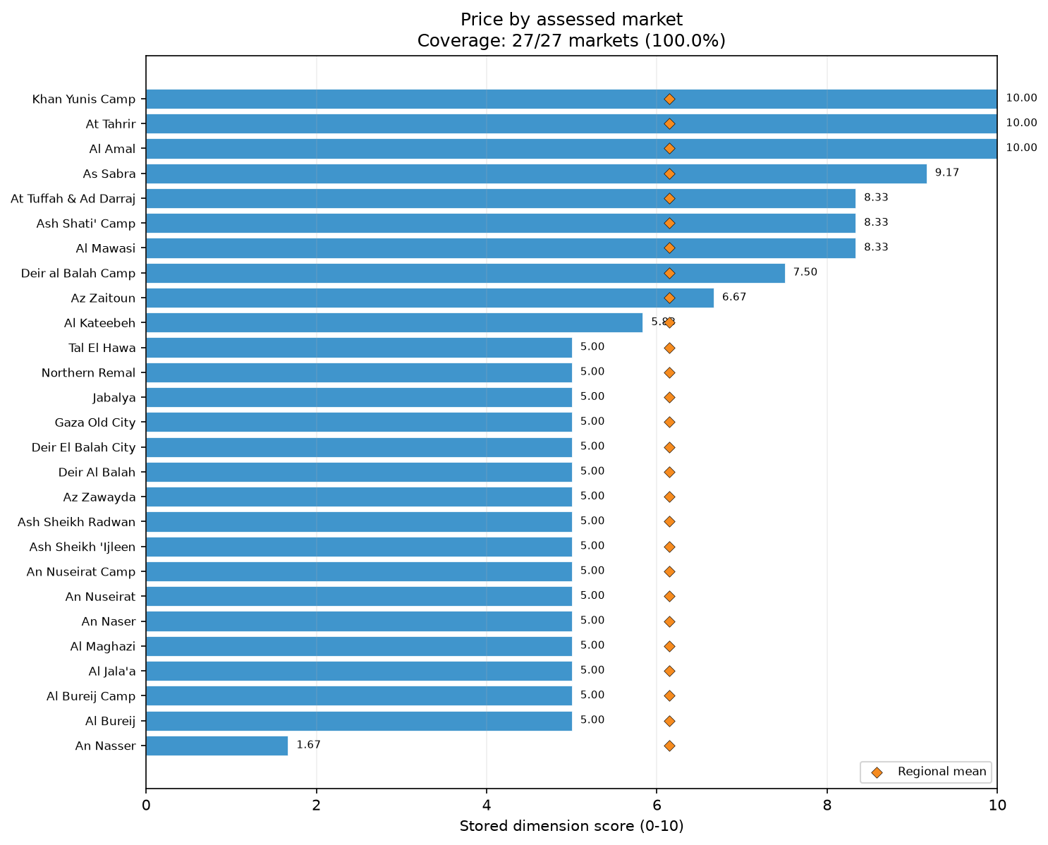
dim price bars
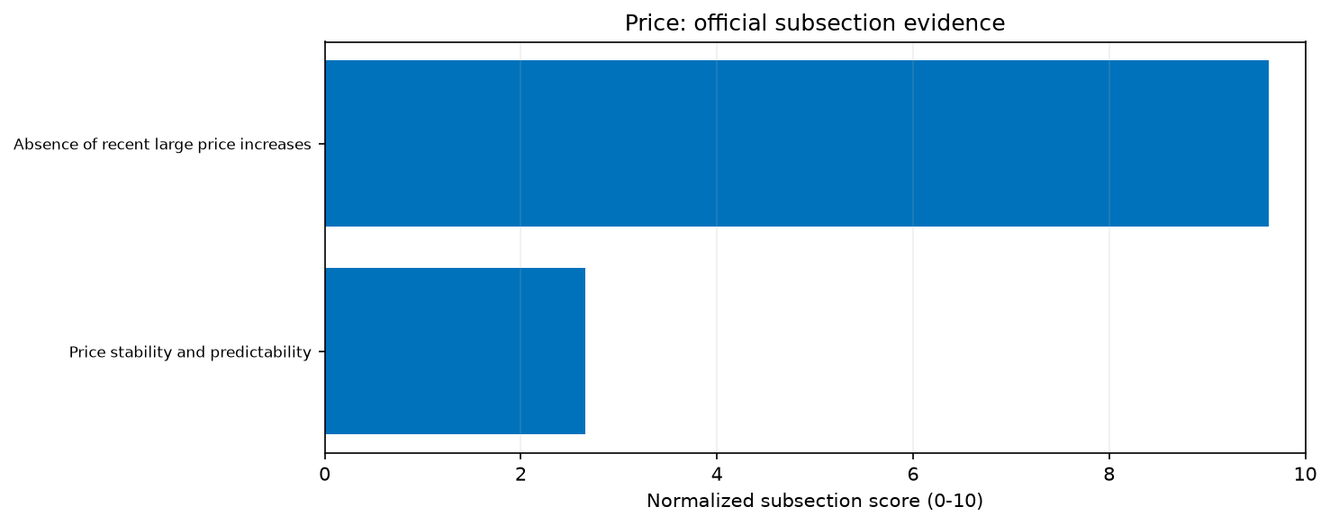
priority price subsections
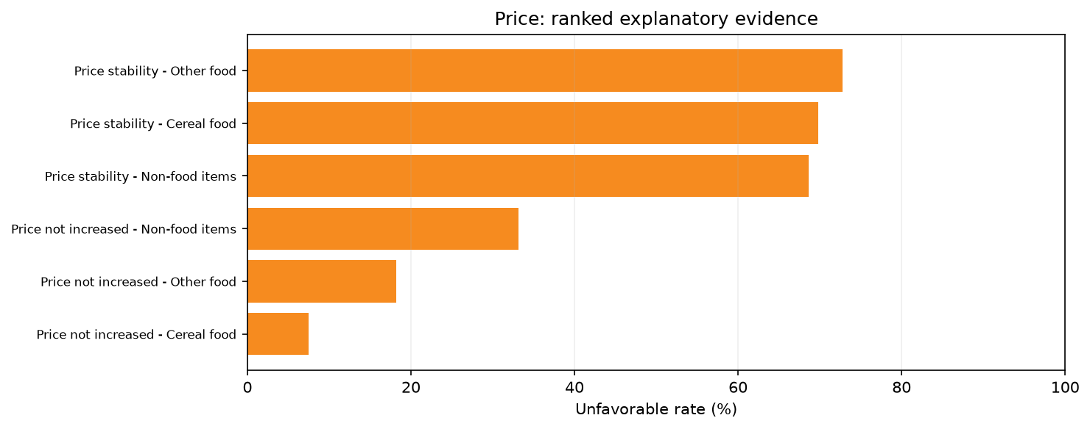
priority price drivers
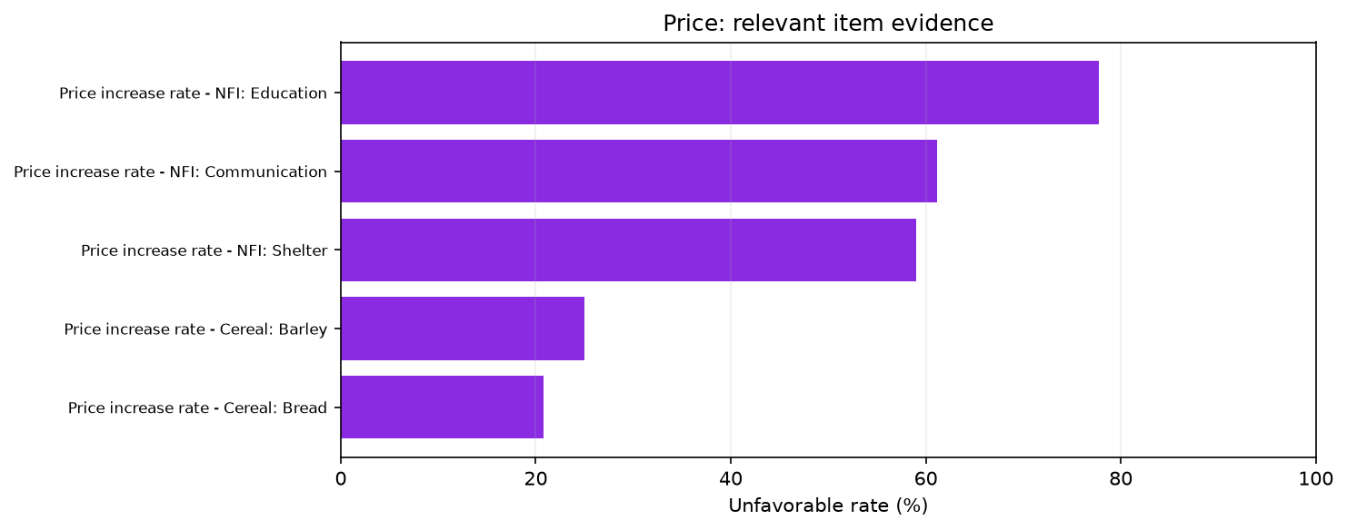
priority price items

Resilience
The unweighted regional mean Resilience score for the Gaza Strip was 7.92/10. 17 of 27 assessed markets scored at or below the median of 7.50/10 for Resilience. 26 of 27 assessed markets scored below 10/10, 21 scored below 9/10, 21 scored below 8/10, and 2 scored below 7/10. The distribution of scores ranged from a minimum of 6.25 to a maximum of 10.0. The overall dimension comprised the Low vulnerability to disruption subsection, which scored 7.35/10 across assessed markets, and the Supply-chain responsiveness subsection, which scored 9.63/10.
Within the Low vulnerability to disruption subsection, the assessed markets demonstrated strong supplier diversity. Assessed markets recorded unweighted mean supplier diversity rates of 7.54/10 for Cereal food, 7.63/10 for Other food, and 7.46/10 for NFI, indicating robust multi-supplier networks. Furthermore, the Absence of single-supplier dependence was extremely high; assessed markets recorded unweighted mean rates of 9.76/10 for Cereal food, 9.78/10 for Other food, and 9.62/10 for NFI. However, the Vulnerability subsection reflected poor Geographic supplier dispersion. Assessed markets recorded unweighted mean geographic dispersion rates of only 3.65/10 for Other food, 3.71/10 for Cereal food, and 4.46/10 for NFI, indicating that supply networks were heavily localized and lacked geographic breadth.
Within the Supply-chain responsiveness subsection, structural supply agility was reflected by rapid expected replenishment times. Assessed markets recorded an unweighted mean rate of 9.35/10 for expecting replenishment within one week. Additionally, assessed markets recorded an unweighted mean rate of 7.30/10 for current stock expected to last at least one week, detailing the operational stockpiles held during the assessment period.
External reporting from July 2026 described continued restrictions on vital aid deliveries, border crossing limitations, and an expanded military buffer zone [S1]. The highly localized geographic dispersion of suppliers coincided with these border and movement restrictions, which likely confined sourcing networks to limited geographic areas within the Gaza Strip. The broader environment of severe conflict and infrastructure damage [S2, S5] occurred alongside these localized supply chain patterns.
The assessment evaluates structural supply chain resilience characteristics and does not predict future logistical continuity under escalating conflict or changing security conditions. Further assessment of geographic sourcing options and supply chain bottlenecks is requested. A persistent limitation is that all summaries are unweighted descriptions of included assessed markets and are not population-representative country estimates. The processed data do not provide reliable item-specific trader denominators, which requires careful interpretation of specific vulnerability metrics. The reliance on highly localized suppliers, as evidenced by the Geographic supplier dispersion scores, represents a structural characteristic of the assessed markets. While the high supplier diversity scores indicate the use of multiple distinct vendors, the lack of geographic spread means that these diverse suppliers operate within restricted spatial boundaries. Recommendations include continued consultation with market actors regarding localized supply constraints and monitoring of supply-chain responsiveness indicators.
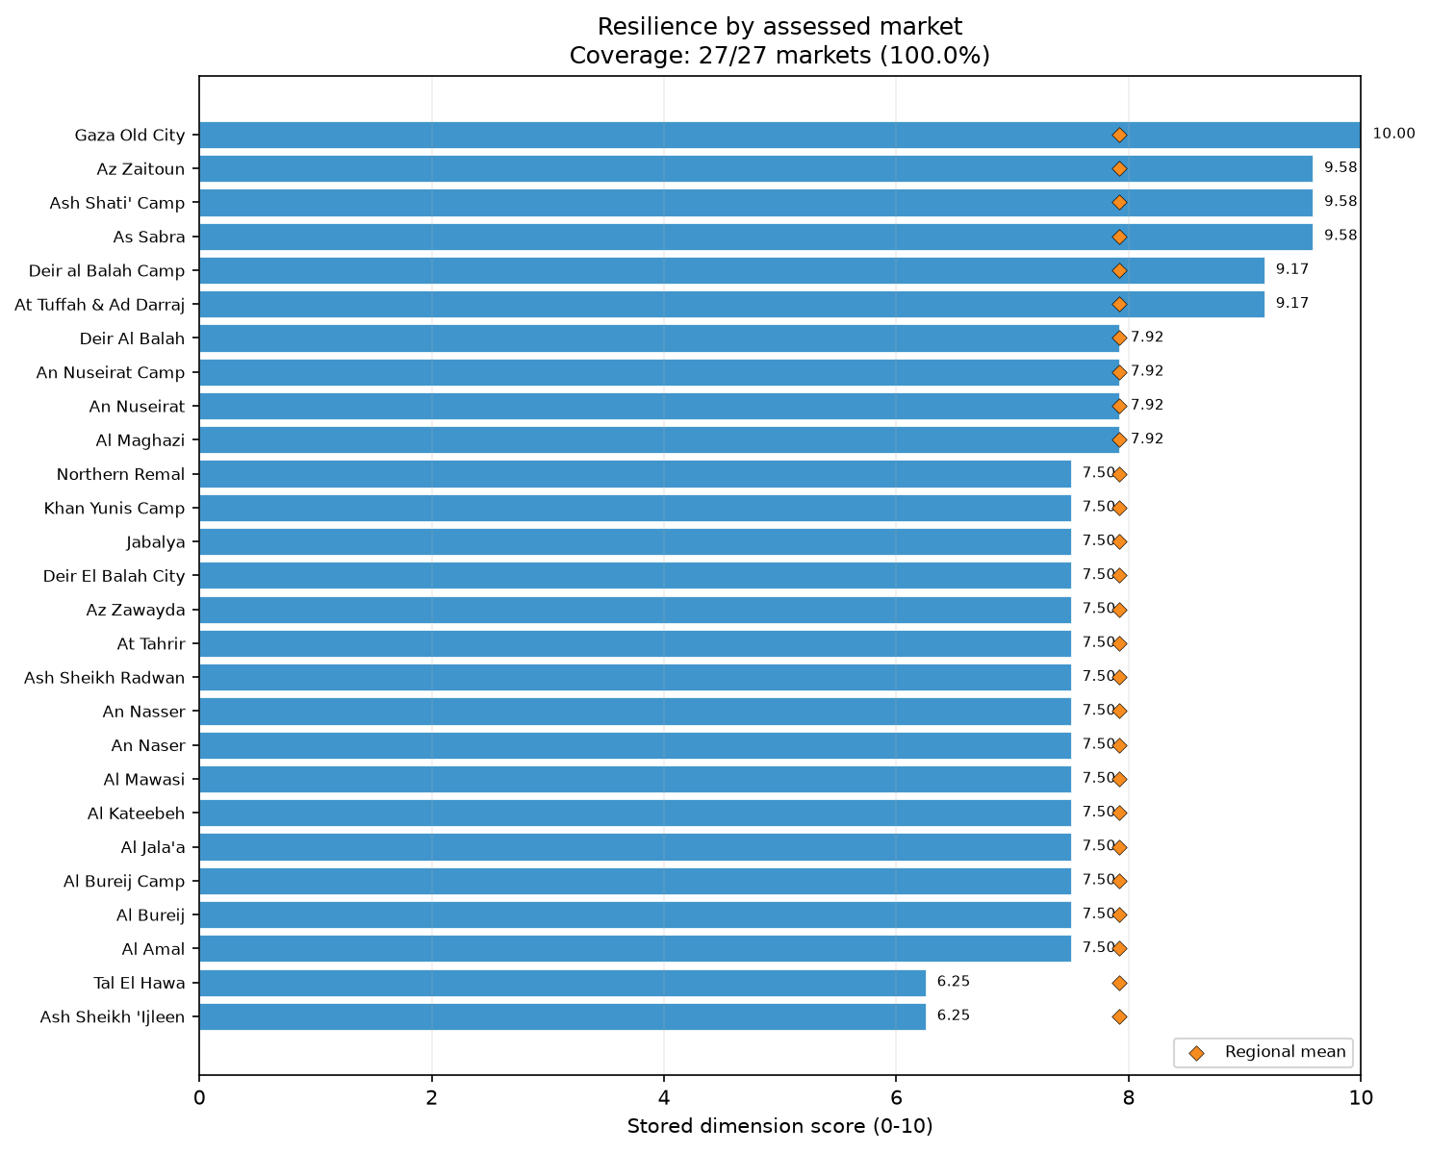
dim resilience bars

Competition
The unweighted regional mean Competition score for the Gaza Strip was 8.49/10. 14 of 27 assessed markets scored at or below the median of 9.17/10 for Competition. 14 of 27 assessed markets scored below 10/10, 11 scored below 9/10, 11 scored below 8/10, 6 scored below 7/10, 3 scored below 6/10, and 1 scored below 5/10. The distribution of scores ranged from a minimum of 4.17 to a maximum of 10.0. The overall dimension comprised the Sufficient trader competition subsection, which scored 7.22/10 across assessed markets, and the Absence of single-trader control subsection, which scored 9.75/10.
Within the Sufficient trader competition subsection, the presence of at least five traders varied distinctly by product group. For Other food, assessed markets recorded the highest concentration score at 9.26/10, indicating a robust number of competing vendors operating within this category. For Non-food items (NFI), assessed markets recorded a concentration score of 7.04/10. Conversely, Cereal food recorded the lowest concentration score of 5.93/10, suggesting fewer operating traders within the essential cereal category and a relatively more concentrated market structure compared to other categories.
Within the Absence of single-trader control subsection, the lack of monopolistic dominance was nearly universal across the assessed markets. For both Cereal food and NFI, assessed markets recorded scores of 9.63/10 for the absence of single-trader control. For Other food, assessed markets achieved a perfect score of 10.00/10, indicating that no single vendor held monopolistic control over this product group.
External context from July 2026 highlighted ongoing governance transitions and the absence of functioning administrative institutions in the region, alongside widespread conflict [S1, S2]. Despite these broader administrative and political challenges, the assessed markets generally maintained competitive environments without significant monopolistic consolidation, although the lower trader concentration in the Cereal food category remains a distinct characteristic of the market structure.
The Competition dimension reflects trader density and control within assessed markets; the evidence does not measure broader market regulation, wholesale market dynamics, or structural barriers to entry. Further verification of trader participation rates in the cereal sector is requested. A critical limitation is that all summaries are authoritative, unweighted descriptions of included assessed markets and are not population-representative country estimates. The processed data do not provide reliable item-specific trader denominators, necessitating caution when interpreting specific category concentration metrics. The disparity between the high scores for the Absence of single-trader control and the moderate scores for Sufficient trader competition reveals a specific market structure. While monopolies are effectively absent, the absolute number of traders, particularly those supplying Cereal food, is not fully expansive. Recommendations include monitoring the operational challenges and structural factors that may restrict new traders from entering the market, particularly in the cereal sector, and conducting further feasibility assessments regarding vendor density.
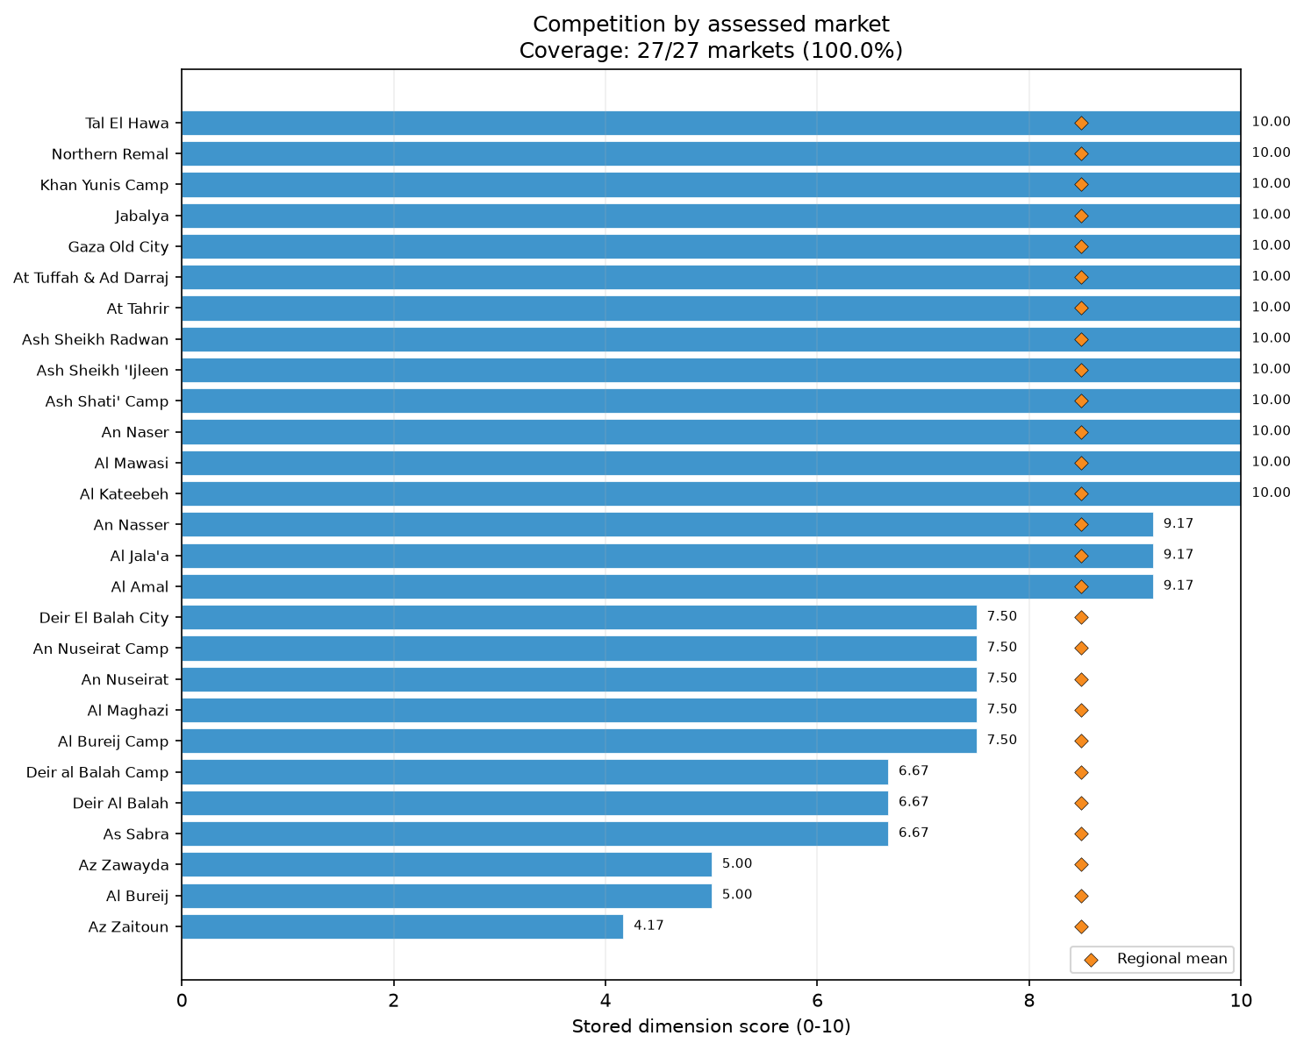
dim competition bars

Infrastructure
The unweighted regional mean Infrastructure score for the Gaza Strip was 6.69/10. 16 of 27 assessed markets scored at or below the median of 7.14/10 for Infrastructure. 27 of 27 assessed markets scored below 10/10, 27 scored below 9/10, 26 scored below 8/10, 10 scored below 7/10, 7 scored below 6/10, 4 scored below 5/10, and 2 scored below 4/10. The distribution of scores ranged from a minimum of 3.57 to a maximum of 8.57, indicating significant variance in physical market conditions. The dimension comprised the Infrastructure condition subsection, which scored 6.67/10 across assessed markets, and the Infrastructure features subsection, which scored 6.71/10.
Within the Infrastructure condition subsection, the physical state of the assessed markets presented varying levels of quality. Assessed markets recorded a Good condition score of 8.15/10. However, the Poor condition metric, which operates as an adverse rate where higher scores indicate worse conditions, recorded a rate of 5.56/10 among assessed markets. The descriptive Medium condition metric was recorded at 8.15/10 across assessed markets, illustrating a mixed structural environment.
Within the Infrastructure features subsection, several foundational physical and utility features remained highly available. Assessed markets recorded high scores for Water availability (9.63/10), Closed sewage systems (9.26/10), Reliable communication networks (9.26/10), Toilets (8.52/10), and Uninterrupted electricity (8.15/10). Dedicated waste collection scored moderately at 5.93/10. Conversely, the subsection reflected a near-total absence of structural safety features. Assessed markets recorded critically low scores of 1.48/10 for both Walkways and emergency exits and physical Shelter.
External context explicitly noted extensive infrastructure damage across the Gaza Strip due to ongoing military activity and conflict [S2]. This external reporting coincided with the high prevalence of poor condition rates and the severe lack of structural shelter and emergency walkways documented in the assessed markets. These structural limitations align with the broader reports of regional destruction [S1, S5].
The Infrastructure scores document the physical environment of the market space exclusively at the time of assessment; the evidence does not establish the broader functionality of municipal utility grids or regional infrastructure stability. Further verification of structural safety capabilities, particularly regarding emergency exits and shelter, is requested. A foundational limitation is that all summaries are unweighted descriptions of included assessed markets and are not population-representative country estimates. The processed data do not provide reliable item-specific trader denominators, requiring careful application of the findings. The robust scores for water, sewage, and communication networks stand in sharp contrast to the degraded structural safety conditions, highlighting a complex operational environment. The lack of dedicated waste collection in numerous markets, combined with the absence of physical shelter from environmental exposure, presents tangible structural factors within the market spaces. Recommendations include continuous monitoring of market site safety and consultation with market actors regarding localized structural repairs that do not assume broader systemic reconstruction.
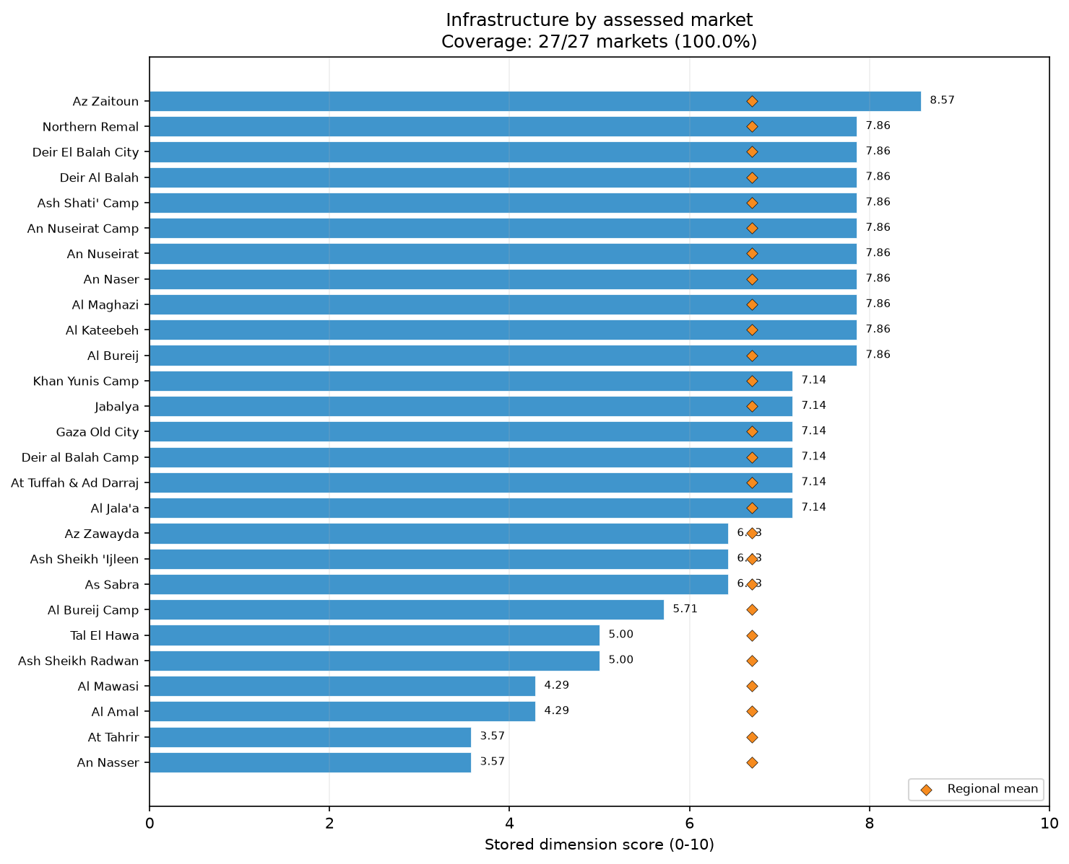
dim infrastructure bars
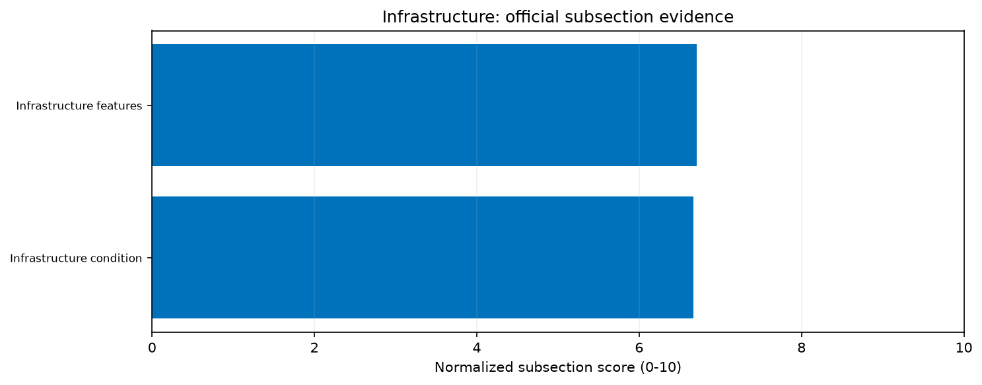
priority infrastructure subsections
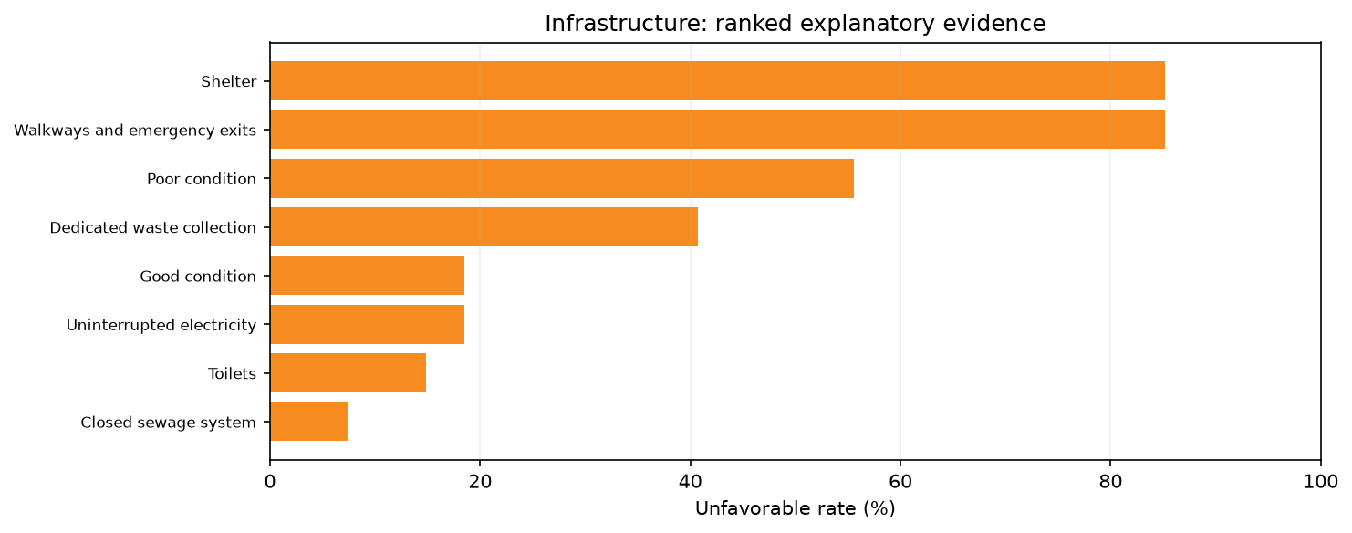
priority infrastructure drivers

Service
The unweighted regional mean Service score for the Gaza Strip was 4.26/10, which represented the lowest score among all nine dimensions. 16 of 27 assessed markets scored at or below the median of 3.33/10 for Service. 27 of 27 assessed markets scored below 10/10, 27 scored below 9/10, 27 scored below 8/10, 27 scored below 7/10, 23 scored below 6/10, 16 scored below 5/10, and 16 scored below 4/10. The distribution of scores was narrow, ranging from a minimum of 3.33 to a maximum of 6.67. The overall dimension comprised the Shopping service subsection, which scored 3.95/10 across assessed markets, and the Checkout service subsection, which scored 4.57/10.
Within the Shopping service subsection, basic retail shopping standards were largely absent. Assessed markets recorded a critically low unweighted mean rate of 0.79/10 for Visible price tags. Remote purchase options were slightly more available but still highly restricted, with assessed markets recording an unweighted mean rate of 2.12/10. Conversely, the physical presentation of goods was maintained, with assessed markets recording an unweighted mean rate of 9.79/10 for Products displayed for easy selection.
Within the Checkout service subsection, modern checkout services exhibited similar systemic limitations. Assessed markets recorded an extremely rare unweighted mean rate of 0.63/10 for the provision of an Automatic itemized receipt. Checkout wait times below ten minutes scored moderately, with assessed markets recording an unweighted mean rate of 4.52/10. The availability of Multiple forms of payment was relatively robust, as assessed markets recorded an unweighted mean rate of 8.63/10.
Contextual reporting for July 2026 focused extensively on regional governance impasses, border restrictions, and ongoing military operations [S1, S2, S5]. However, no specific external documentation was available regarding retail service standards in the Gaza Strip. The analysis relies solely on the assessment data, which indicated pervasive constraints on sophisticated retail services and transparent pricing mechanisms within the surveyed markets.
The Service dimension evaluates retail practices and checkout capabilities at the specific market sites; the evidence does not infer broader programme feasibility, consumer preferences, or financial inclusion. Further verification of retail service capacities is requested. A known limitation is that all summaries are unweighted descriptions of included assessed markets and are not population-representative country estimates. Additionally, item eligibility uses assessed-market coverage, and the processed data do not provide reliable item-specific trader denominators, necessitating caution when interpreting these specific service metrics. The stark contrast between the high scores for product display and the exceptionally low scores for visible pricing and automated receipts indicates that retail operations rely almost entirely on informal, direct negotiations rather than standardized retail practices. The moderate wait times for checkout further reflect that while formal checkout infrastructure is lacking, basic transactional throughput is occurring. Recommendations include continuous monitoring of payment modality acceptance and service infrastructure, alongside further feasibility assessments.
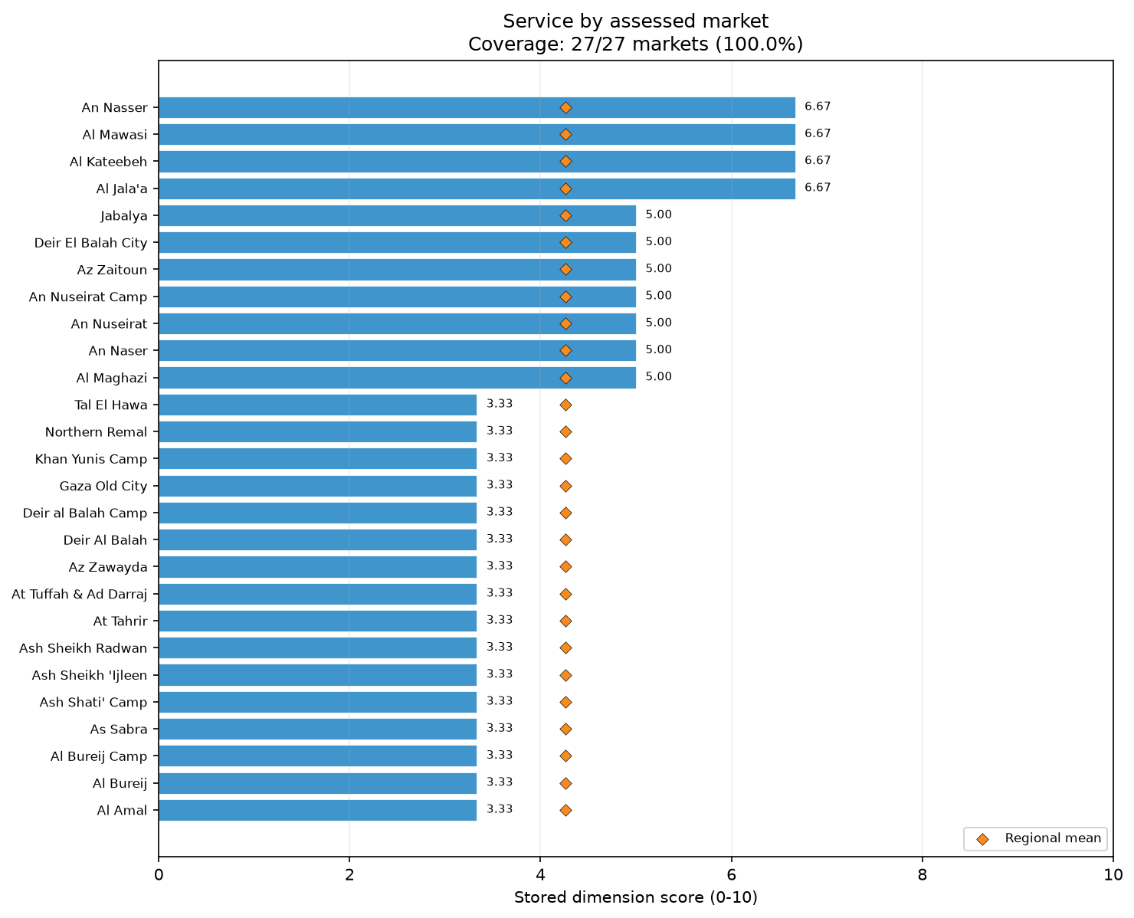
dim service bars
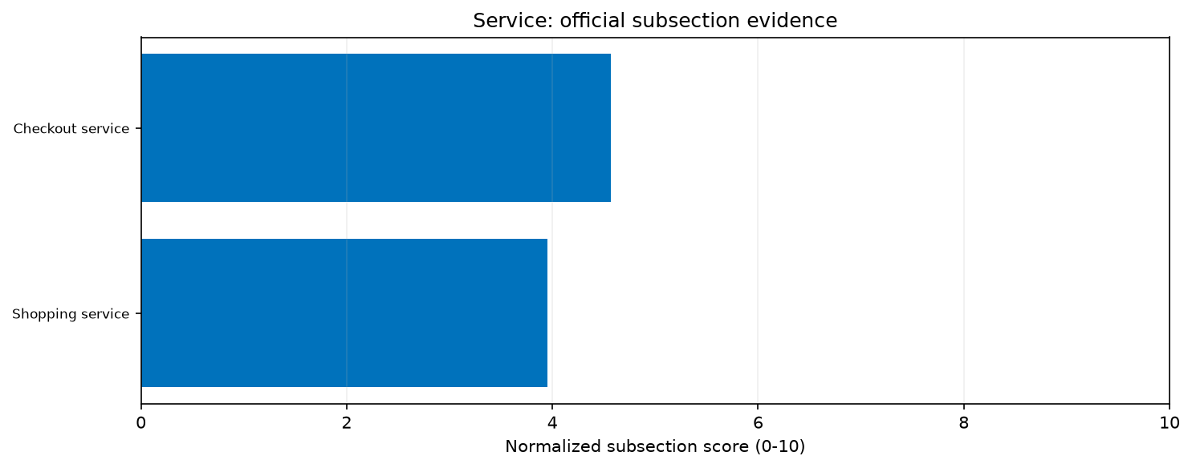
priority service subsections
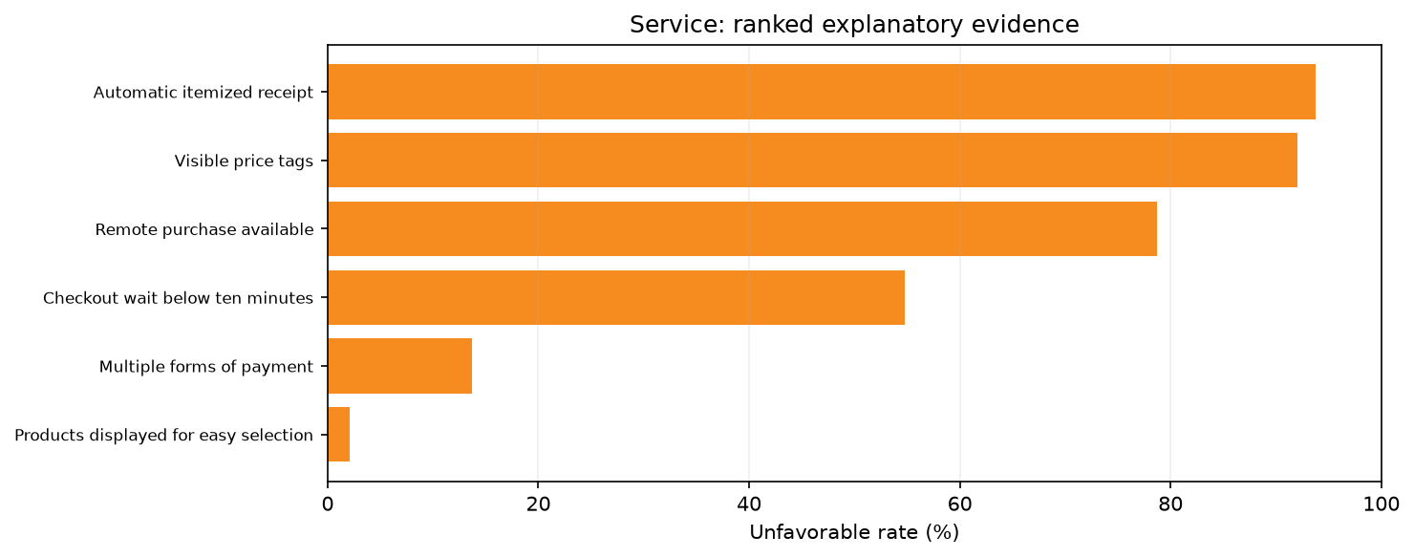
priority service drivers

Food Quality
The unweighted regional mean Food Quality score for the Gaza Strip was 9.44/10. 27 of 27 assessed markets scored at or below the median of 10.00/10 for Food Quality. 9 of 27 assessed markets scored below 10/10, 9 scored below 9/10, 2 scored below 8/10, and 1 scored below 7/10. The distribution of scores ranged from a minimum of 6.25 to a maximum of 10.0. The overall dimension was evaluated through the Applicable quality conditions satisfied metric, which scored 9.44/10 across assessed markets, and filtered by the Applicable quality conditions descriptive component, which recorded a score of 8.00/10.
Within the quality measurement components, food quality conditions were generally highly satisfied across the assessed markets. Assessed markets achieved perfect unweighted mean rates of 10.00/10 for multiple critical metrics, including No visible spoilage, Food protected from contaminants, Packaging intact, and Fresh food separated from animal-origin food. High compliance was also recorded for the requirement that Applicable food be refrigerated, which achieved an unweighted mean rate of 9.63/10 across assessed markets. Similarly, the condition that Prepackaged food be intact and labelled recorded an unweighted mean rate of 9.63/10. The dimension reflected slight rate reductions in two specific areas: Continuous refrigeration working and Products not expired both recorded unweighted mean rates of 8.15/10 across assessed markets.
External reporting from July 2026 described extensive infrastructure damage, ongoing military conflict, and disruptions to essential utility grids across the region [S1, S2]. While these severe external conditions coincided with the assessment period, the assessed markets maintained high levels of observable food quality, protection, and separation practices. The slight reductions in continuous refrigeration functionality align with the broader operational challenges and infrastructure damage facing the region [S5].
The assessment measures visually observable food quality compliance strictly at the market level; the evidence does not represent laboratory testing, comprehensive health standards, or systemic food safety outcomes. Further monitoring of continuous refrigeration capabilities is requested. A recognized limitation of this analysis is that all summaries are unweighted descriptions of included assessed markets and are not population-representative country estimates. The processed data do not provide reliable item-specific trader denominators. Furthermore, the specialized Food Quality methodology preserves validation components that do not behave as standard normative metrics, necessitating specialized interpretation. The perfect scores achieved for the separation of fresh and animal-origin foods, alongside the complete absence of visible spoilage, identify strong foundational handling practices among the surveyed vendors. The vendors effectively shielded food from contaminants and maintained intact packaging within the market environment. Recommendations include continued consultation with market actors regarding the specific constraints limiting continuous refrigeration, ensuring that structural barriers to cold chain continuity are carefully monitored and evaluated through further feasibility assessments.
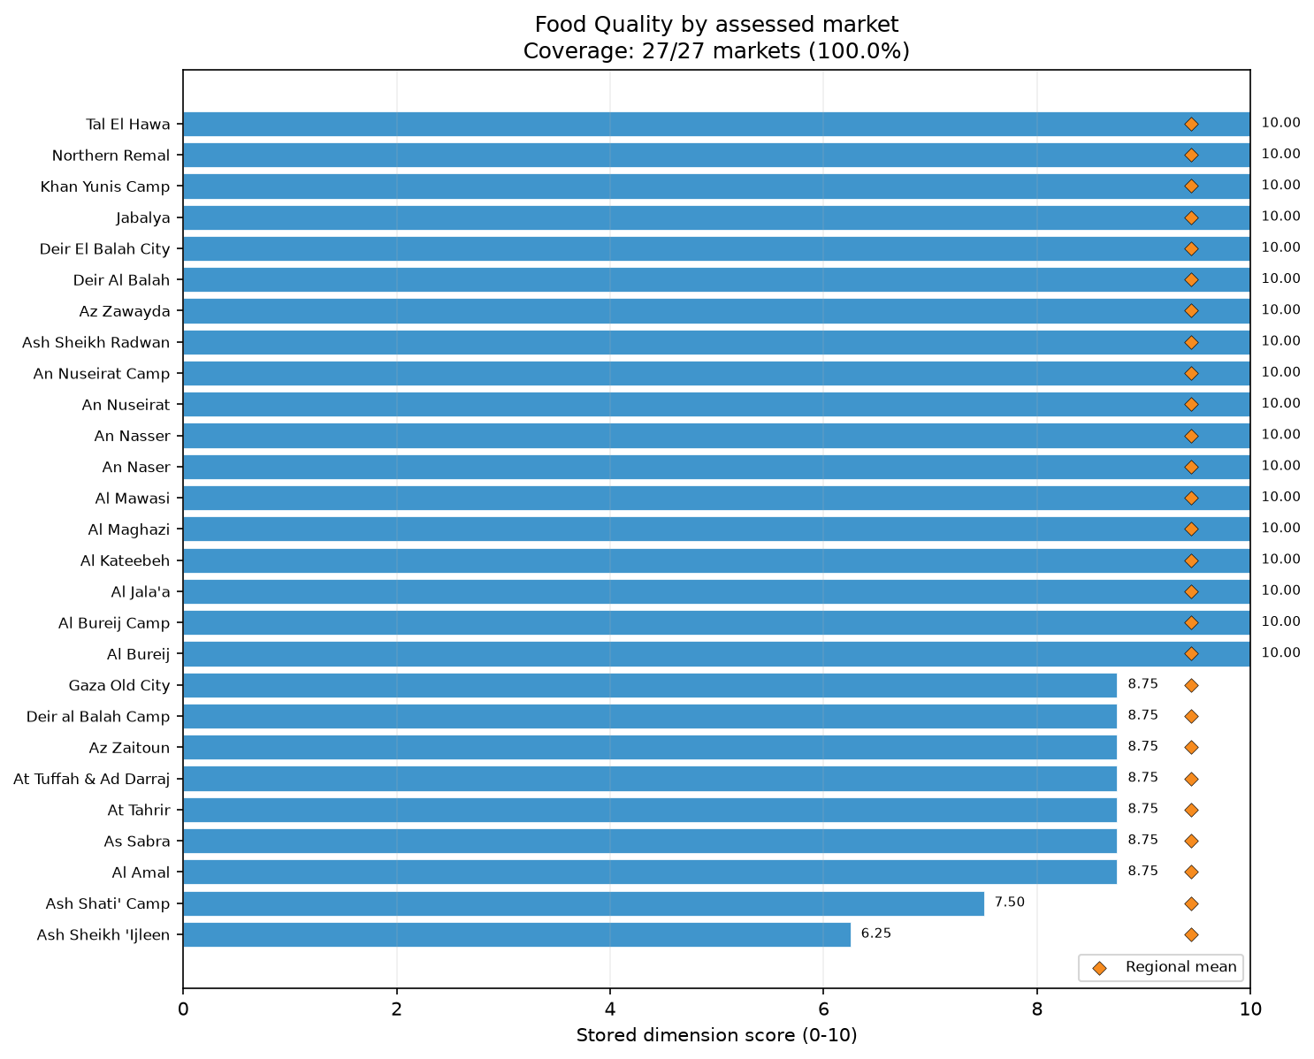
dim food quality bars

Access & Protection
The unweighted regional mean Access & Protection score for the Gaza Strip was 9.85/10. 27 of 27 assessed markets scored at or below the median of 10.00/10 for Access & Protection. 2 of 27 assessed markets scored below 10/10, 1 scored below 9/10, 1 scored below 8/10, and 1 scored below 7/10. The distribution of scores was exceptionally tight, ranging from a minimum of 6.67 to a maximum of 10.0. The overall dimension comprised the Protection and security subsection, which scored 9.81/10 across assessed markets, and the Physical access subsection, which scored 9.88/10.
Within the Physical access subsection, site accessibility to the assessed markets was widely preserved according to the assessment data. Assessed markets recorded perfect unweighted mean rates of 10.00/10 for the absence of disaster-related access limitations and the absence of seasonal access difficulties. Furthermore, proximity to a major road network scored highly, achieving an unweighted mean rate of 9.26/10 across assessed markets.
Within the Protection and security subsection, protection conditions were reported as universally high within the specific market spaces. Assessed markets recorded perfect unweighted mean rates of 10.00/10 for the absence of physical threats and the absence of social barriers. Additionally, the absence of a general security issue recorded an unweighted mean rate of 9.63/10 among assessed markets.
External context sharply diverged from the positive assessment scores. Reports from July 2026 detailed ongoing Israeli military operations, strikes on individuals, extensive infrastructure damage, and UN verification of over 1,000 Palestinian deaths since the October 2025 ceasefire [S1, S2, S5]. The high access and protection scores reported within the specific confines of the assessed markets occurred alongside this broader regional environment of extreme war risk and ongoing conflict.
The Access & Protection dimension measures conditions exclusively at the specific market site during the exact time of assessment; the evidence does not reflect the broader security environment, the safety of transit routes to the market, or the long-term protection of consumers and traders. Further verification and continuous monitoring of market accessibility are requested. A significant limitation is that all summaries are unweighted descriptions of included assessed markets and are not population-representative country estimates. The processed data do not provide reliable item-specific trader denominators, requiring careful application of the findings. The profound contrast between the assessment data and the external conflict reporting highlights the highly localized nature of the MFI methodology. The assessment indicates that, strictly within the operational bounds of the surveyed market spaces and at the specific moments they were surveyed, general security issues and physical threats did not appear to be present. However, this does not infer safety beyond the immediate market perimeter or project future security conditions. Recommendations include conducting feasibility assessments and continuous security monitoring before finalizing programmatic access planning.
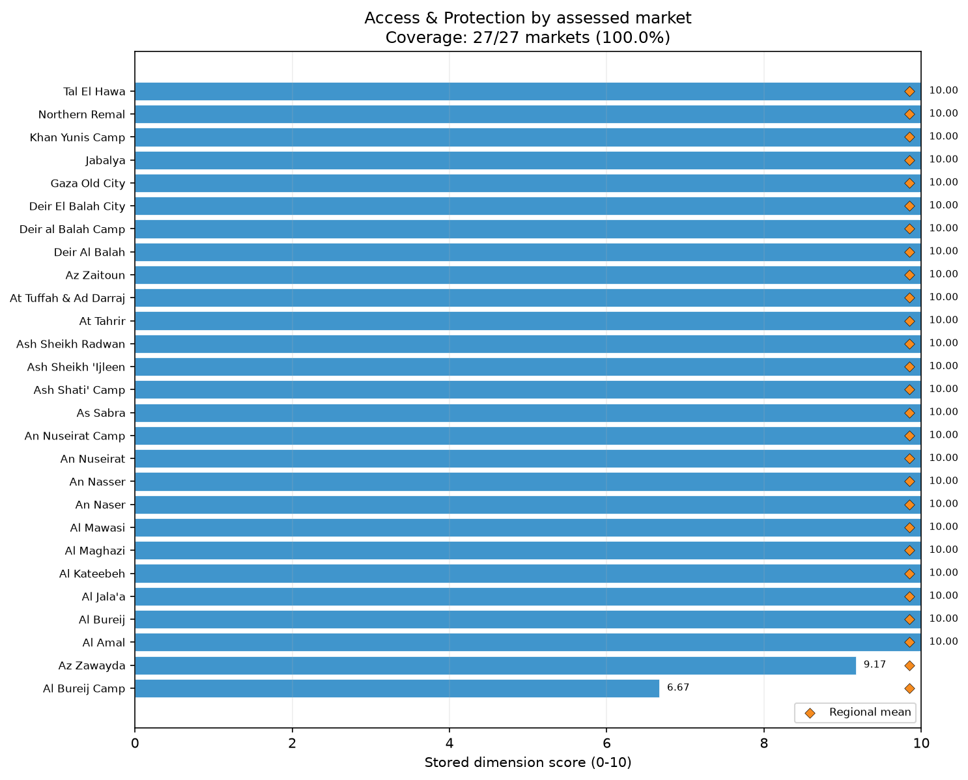
dim access and protection bars

Selected markets

An Nasser
The assessment of An Nasser market recorded an overall Market Functionality Index of 4.3, the lowest in the sample. The most constrained dimensions were Price (1.7), Availability (2.5), and Infrastructure (3.6). Within the Price dimension, the normalized score recorded for this market was 0.0 for price stability and 3.3 for the absence of recent large price increases. The proportion of surveyed traders in this market reporting the unfavorable condition was 80% for other food price stability, 75% for cereal food price stability, and 67% for non-food item price stability. The proportion of surveyed traders in this market reporting the unfavorable condition for price increase rates was 100% for barley, bread, and education NFIs. For Availability, the normalized score recorded for this market was 1.7 for the absence of imminent runout and 3.3 for the absence of scarcity. The proportion of surveyed traders in this market reporting the unfavorable condition was 75% for both cereal food runout and scarcity, and 100% for barley runout and scarcity. Regarding Infrastructure, the condition recorded for this market was 100% unfavorable for good condition, closed sewage, electricity, and shelter. Recommendations include further monitoring of price and availability constraints, and feasibility assessments for infrastructure improvements. A key limitation is that item eligibility uses assessed-market coverage, and the processed data do not provide reliable item-specific trader denominators. Furthermore, all summaries are unweighted descriptions of included assessed markets and are not population-representative estimates.

Az Zawayda
Az Zawayda market recorded an overall MFI of 4.5. The most constrained dimensions were Assortment (2.0), Service (3.3), and Price and Competition (both 5.0). Within Assortment, the normalized score recorded for this market was 0.0 for depth and 2.9 for breadth. The proportion of surveyed traders in this market reporting the unfavorable condition was 100% for communication, education, health, and household items, as well as for cassava, other cereal, and sorghum. For Service, the checkout and shopping normalized scores recorded for this market were both 3.3. The proportion of surveyed traders in this market reporting the unfavorable condition was 100% for automatic itemized receipts, short waits, remote purchases, and visible price tags. In the Price dimension, the price stability normalized score recorded for this market was 0.0. The proportion of surveyed traders in this market reporting the unfavorable condition was 100% for both cereal food and NFI price stability. Competition recorded a concentration normalized score of 0.0, with the condition recorded for this market being 100% unfavorable for the concentration of cereal food, NFIs, and other food. Recommendations include monitoring assortment and competition constraints, alongside further consultation on service improvements. Data limitations include the lack of reliable item-specific trader denominators and the unweighted, descriptive nature of the market summaries.

Al Bureij Camp
The overall MFI for Al Bureij Camp was 5.2. Priority constraints were identified in Service (3.3), Assortment (4.0), and Price (5.0). Service recorded a normalized score of 3.3 for both checkout and shopping. The proportion of surveyed traders in this market reporting the unfavorable condition was 100% for visible price tags, 93% for short checkout waits and remote purchases, and 87% for automatic itemized receipts. In the Assortment dimension, the depth normalized score recorded for this market was 0.0, and the breadth normalized score was 5.7. The proportion of surveyed traders in this market reporting the unfavorable condition for assortment breadth was 100% for communication, education, and shelter NFIs, as well as for cassava, other cereal, and sorghum. The Price dimension showed a stability normalized score of 0.0. The proportion of surveyed traders in this market reporting the unfavorable condition was 100% for cereal food price stability, 91% for other food, and 71% for NFIs. Recommendations include monitoring service and assortment gaps, and verifying price stability constraints. Analysis is limited by the unweighted descriptive nature of the summaries, and the lack of reliable item-specific trader denominators based on the processed data.

Ash Sheikh 'Ijleen
Ash Sheikh 'Ijleen market recorded an overall MFI of 5.2. The primary constraints were Service (3.3), Price (5.0), and Assortment (6.0). Within the Service dimension, the normalized score recorded for this market was 3.3 for both checkout and shopping. The proportion of surveyed traders in this market reporting the unfavorable condition was 100% for automatic receipts, short checkout waits, and remote purchases, and 93% for visible price tags. For the Price dimension, the price stability normalized score recorded for this market was 0.0. The proportion of surveyed traders in this market reporting the unfavorable condition was 100% for the price stability of cereal food, NFIs, and other food. In Assortment, the depth normalized score recorded for this market was 3.3, and the breadth normalized score was 7.1. The proportion of surveyed traders in this market reporting the unfavorable condition for assortment breadth was 100% for education and shelter NFIs, as well as cassava, other cereal, and sorghum. Recommendations are limited to further verification of price constraints and feasibility assessments for service enhancements. Limitations include that summaries are not population-representative estimates and item-specific trader denominators remain unavailable.

Al Bureij
The Al Bureij market's overall MFI was 5.4, with the most severe constraints noted in Service (3.3), Assortment (4.0), and both Price and Competition (5.0). Service recorded a normalized score of 3.3 for both checkout and shopping. The proportion of surveyed traders in this market reporting the unfavorable condition was 100% across all measured service components: automatic receipts, short waits, remote purchases, and visible prices. In Assortment, the depth normalized score recorded for this market was 0.0, and the breadth normalized score was 5.7. The proportion of surveyed traders in this market reporting the unfavorable condition for assortment breadth was 100% for communication, education, and health NFIs, as well as for cassava, other cereal, and sorghum. The Price dimension had a stability normalized score of 0.0. The proportion of surveyed traders in this market reporting the unfavorable condition was 100% for cereal food stability, 83% for other food, and 80% for NFIs. For Competition, the concentration normalized score recorded for this market was 0.0, with the condition recorded for this market being 100% unfavorable for cereal food, NFI, and other food concentration. Recommendations involve monitoring assortment and competition constraints, and consulting on service capacities. Limitations apply regarding unweighted summaries and item-trader denominators.

Al Jala'a
Al Jala'a market achieved an overall MFI of 5.6. The most constrained dimensions were Availability (3.3), Price (5.0), and Service (6.7). Within Availability, the runout normalized score recorded for this market was 1.7. The proportion of surveyed traders in this market reporting the unfavorable condition was 67% for cereal food runout, and 57% for both other food runout and scarcity, as well as NFI scarcity. For Price, the stability normalized score recorded for this market was 0.0, and the absence of recent large price increases normalized score was 10.0. The proportion of surveyed traders in this market reporting the unfavorable condition was 100% for NFI and other food stability, and 83% for cereal food stability. Furthermore, the proportion of surveyed traders in this market reporting the unfavorable condition was 50% for bread price increases. In the Service dimension, checkout and shopping normalized scores recorded for this market were 6.7. The proportion of surveyed traders in this market reporting the unfavorable condition was 100% for automatic receipts and visible prices. Recommendations include further verification of availability and price constraints, and consultations regarding service elements. Analysis limitations note that these descriptions are not population-representative, and item-specific trader denominators are unavailable.

Deir al Balah Camp
Deir al Balah Camp market recorded an overall MFI of 5.6. Priority weaknesses emerged in Service (3.3), Assortment (4.0), and Competition (6.7). The Service dimension showed checkout and shopping normalized scores of 3.3. The proportion of surveyed traders in this market reporting the unfavorable condition was 100% for automatic receipts, short wait times, remote purchases, and visible price tags. In Assortment, the depth normalized score recorded for this market was 0.0, and the breadth normalized score was 5.7. The proportion of surveyed traders in this market reporting the unfavorable condition for assortment breadth was 100% for communication, education, and health NFIs, alongside cassava, other cereal, and sorghum items. Competition recorded a concentration normalized score of 3.3. The condition recorded for this market was 100% unfavorable for the concentration of cereal food and NFIs. Recommendations suggest monitoring service and assortment constraints, and conducting feasibility assessments to address competition issues. It should be noted that market summaries describe only assessed coverage and are not population-representative estimates, while specific item-level trader denominators are unavailable.

Deir Al Balah
Deir Al Balah market's overall MFI stood at 5.6. The most prominent constraints were in Service (3.3), Price (5.0), and Assortment (6.0). Within Service, both checkout and shopping recorded a normalized score of 3.3. The proportion of surveyed traders in this market reporting the unfavorable condition was 93% for remote purchases, 87% for visible prices, 83% for automatic receipts, and 60% for short waits. In the Price dimension, the stability normalized score recorded for this market was 0.0. The proportion of surveyed traders in this market reporting the unfavorable condition was 100% for cereal food stability, 92% for other food stability, and 78% for NFI stability. For Assortment, the depth normalized score recorded for this market was 3.3, and the breadth normalized score was 7.1. The proportion of surveyed traders in this market reporting the unfavorable condition for assortment breadth was 100% for communication and shelter NFIs, as well as cassava, other cereal, and roots and tubers. Recommendations include monitoring price and assortment constraints. As a limitation, data represent unweighted descriptions rather than population-representative estimates, and item trader denominators are not fully available.

Tal El Hawa
Tal El Hawa market recorded an overall MFI of 5.7. The weakest dimensions were Service (3.3), alongside Price and Infrastructure (both 5.0). Regional context highlights widespread conflict and destruction [S1, S2], which corroborates the infrastructure findings. Service recorded a normalized score of 3.3 for checkout and shopping. The proportion of surveyed traders in this market reporting the unfavorable condition was 100% for automatic receipts, short checkout waits, and remote purchases, and 93% for visible prices. In the Price dimension, the stability normalized score recorded for this market was 0.0, and the absence of recent large price increases normalized score was 10.0. The proportion of surveyed traders in this market reporting the unfavorable condition was 100% for cereal food and other food stability, and 87.5% for NFI stability. The proportion of surveyed traders in this market reporting the unfavorable condition was 50% for NFI price increases. Infrastructure features recorded a normalized score of 6.2, while condition scored 3.3. The condition recorded for this market was 100% unfavorable regarding good condition, shelter, walkways and exits, and dedicated waste collection. Recommendations involve feasibility assessments for infrastructure repairs and monitoring of service and price limitations. Analysis remains constrained by the unweighted nature of the data and unavailable item trader denominators.

Ash Sheikh Radwan
The overall MFI for Ash Sheikh Radwan was 5.8. The primary constraints were identified in Service (3.3), Price (5.0), and Infrastructure (5.0). Within Service, the checkout and shopping normalized scores recorded for this market were 3.3. The proportion of surveyed traders in this market reporting the unfavorable condition was 100% for remote purchases, and 95% for automatic receipts, short waits, and visible prices. For Price, the stability normalized score recorded for this market was 0.0, and the absence of recent large price increases normalized score was 10.0. The proportion of surveyed traders in this market reporting the unfavorable condition was 100% for the price stability of cereal food, NFIs, and other food. The proportion of surveyed traders in this market reporting the unfavorable condition was 100% for NFI communication price increases. In Infrastructure, the condition normalized score recorded for this market was 3.3. The condition recorded for this market was 100% unfavorable regarding good condition, shelter, walkways and exits, and waste collection. Recommendations include assessing infrastructure feasibility and monitoring price stability. Limitations include the lack of population-representative estimates and the unavailability of item-specific trader denominators.

Al Amal
Al Amal market achieved an overall MFI of 5.9. The weakest dimensions were Service (3.3), Infrastructure (4.3), and Resilience (7.5). Service recorded checkout and shopping normalized scores of 3.3. The proportion of surveyed traders in this market reporting the unfavorable condition was 100% for automatic receipts and remote purchases, and 87% for multiple payments and visible prices. Within Infrastructure, the features normalized score recorded for this market was 1.2. The condition recorded for this market was 100% unfavorable for closed sewage systems, communication networks, electricity, and shelter. In Resilience, the vulnerability normalized score recorded for this market was 6.7, and the responsiveness normalized score was 10.0. The proportion of surveyed traders in this market reporting the unfavorable condition was 100% for geographic supplier dispersion across cereal food, NFIs, and other food. Additionally, the proportion of surveyed traders in this market reporting the unfavorable condition was 13.3% for replenishment lead times. Recommendations involve conducting feasibility assessments for infrastructure components and monitoring resilience constraints. Market summaries represent only unweighted coverage and lack reliable item-specific trader denominators.

At Tahrir
The At Tahrir market recorded an overall MFI of 5.9. The most constrained dimensions were Service (3.3), Infrastructure (3.6), and Resilience (7.5). In the Service dimension, checkout and shopping recorded a normalized score of 3.3. The proportion of surveyed traders in this market reporting the unfavorable condition was 100% for automatic receipts, 97% for visible prices, 67% for remote purchases, and 60% for multiple payments. Infrastructure condition recorded a normalized score of 1.7. The condition recorded for this market was 100% unfavorable regarding both good condition and the absence of poor condition, as well as for electricity and shelter features. For Resilience, the vulnerability normalized score recorded for this market was 6.7, and the responsiveness normalized score was 10.0. The proportion of surveyed traders in this market reporting the unfavorable condition was 100% for supplier density across cereal food, NFIs, and other food, while the proportion of surveyed traders in this market reporting the unfavorable condition was 22.5% for current stock. Recommendations include monitoring resilience and assessing the feasibility of infrastructure repairs. Limitations involve the unweighted description of the assessed markets and the lack of specific item-level denominators.

As Sabra
As Sabra market registered an overall MFI of 6.0, with principal weaknesses in Service (3.3), Infrastructure (6.4), and Competition (6.7). Within Service, the checkout and shopping normalized scores recorded for this market were 3.3. The proportion of surveyed traders in this market reporting the unfavorable condition was 100% for automatic receipts, 93% for short wait times, 73% for visible prices, and 67% for remote purchases. In Infrastructure, the condition normalized score recorded for this market was 6.7, and the features normalized score was 6.3. The condition recorded for this market was 100% unfavorable for the absence of poor condition, and 100% unfavorable for the features of uninterrupted electricity, shelter, and walkways and exits. Competition recorded a concentration normalized score of 5.0 and a monopoly score of 8.3. The condition recorded for this market was 100% unfavorable for cereal food concentration and the absence of single-trader control for NFIs. Recommendations suggest monitoring service gaps and competition, and assessing infrastructure feasibility. Limitations apply regarding the unweighted reporting and missing item-trader denominators.

Gaza Old City
The Gaza Old City market recorded an overall MFI of 6.0. Service (3.3), Price (5.0), and Infrastructure (7.1) were the most constrained dimensions. Service checkout and shopping normalized scores were 3.3. The proportion of surveyed traders in this market reporting the unfavorable condition was 94% for short waits, 87.5% for visible prices, 78% for automatic receipts, and 75% for remote purchases. For Price, the stability normalized score recorded for this market was 0.0, and the absence of recent large price increases normalized score was 10.0. The proportion of surveyed traders in this market reporting the unfavorable condition was 79% for other food stability, 78% for cereal food, and 57% for NFIs. The proportion of surveyed traders in this market reporting the unfavorable condition was 100% for price increases in communication, education, and shelter NFIs. In Infrastructure, the condition normalized score recorded for this market was 6.7. The condition recorded for this market was 100% unfavorable regarding poor condition, shelter, walkways, and good condition. Recommendations include further verification of price constraints and feasibility assessments for infrastructure. Limitations note that unweighted descriptions are used and item-specific denominators are missing.

Northern Remal
The overall MFI for Northern Remal was 6.0. The most prominent priority constraints were Service (3.3), Price (5.0), and Resilience (7.5). Service recorded checkout and shopping normalized scores of 3.3. The proportion of surveyed traders in this market reporting the unfavorable condition was 100% for automatic receipts and remote purchases, 96% for visible prices, and 67% for short waits. In the Price dimension, the stability normalized score recorded for this market was 0.0, and the absence of recent large price increases normalized score was 10.0. The proportion of surveyed traders in this market reporting the unfavorable condition was 100% for cereal and other food stability, and 90% for NFI stability. The proportion of surveyed traders in this market reporting the unfavorable condition was 100% for communication NFI price increases. Resilience recorded a vulnerability normalized score of 6.7, and a responsiveness normalized score of 10.0. The proportion of surveyed traders in this market reporting the unfavorable condition was 86% for other food supplier diversity, and 80% for both cereal food and NFIs. The proportion of surveyed traders in this market reporting the unfavorable condition was 39.2% for current stock responsiveness. Recommendations include monitoring resilience vulnerabilities and verifying price constraints. Data represent unweighted assessments rather than population-level estimates, with limited item-specific denominators available.

Analytical annex: complete dimension evidence

Assortment

Assortment: unweighted score distribution (0–10)
Statistic | Score
Mean | 7.78
Median | 9.00
Minimum | 2.00
Maximum | 10.00
Q1 | 6.50
Q3 | 9.50
Iqr | 3.00
Score Range | 8.00

Assortment: local extremes, including all ties
Market | Score /10 | Comparison
Az Zawayda | 2.00 | Minimum
An Naser | 10.00 | Maximum
As Sabra | 10.00 | Maximum
Ash Shati' Camp | 10.00 | Maximum
At Tuffah & Ad Darraj | 10.00 | Maximum
Gaza Old City | 10.00 | Maximum
Jabalya | 10.00 | Maximum
Northern Remal | 10.00 | Maximum

Assortment: complete regional comparisons
Region | Mean /10 | Markets
Gaza Strip | 7.78 | 27

Assortment: Official subsections and special scoring components
Indicator | Raw mean | Normalized /10 | Adverse rate | Markets | Evidence / applicability
Assortment depth | 2.59 | 5.31 | -159.3% | 27/27 | Observed
Assortment breadth | 7.19 | 8.84 | -618.5% | 27/27 | Observed

Assortment: Fixed drivers and product indicators
Indicator | Raw mean | Normalized /10 | Adverse rate | Markets | Evidence / applicability
NFI - shelter | 0.70 | 7.04 | 29.6% | 27/27 | Observed
Cereal assortment - Cassava | 0.00 | 0.00 | 100.0% | 27/27 | Observed
NFI - communication | 0.81 | 8.15 | 18.5% | 27/27 | Observed
NFI - education | 0.81 | 8.15 | 18.5% | 27/27 | Observed
Cereal assortment - Other cereal | 0.01 | 0.06 | 99.4% | 27/27 | Observed
Cereal assortment - Sorghum | 0.01 | 0.11 | 98.9% | 27/27 | Observed
NFI - health | 0.89 | 8.89 | 11.1% | 27/27 | Observed
Other food assortment - Other non-cereal food | 0.06 | 0.57 | 94.3% | 27/27 | Observed
NFI - household items | 0.96 | 9.63 | 3.7% | 27/27 | Observed
Cereal assortment - Millet | 0.08 | 0.83 | 91.7% | 27/27 | Observed; not selected by item eligibility rule
Cereal food | 1.00 | 10.00 | 0.0% | 27/27 | Observed
Other food | 1.00 | 10.00 | 0.0% | 27/27 | Observed
NFI - WASH | 1.00 | 10.00 | 0.0% | 27/27 | Observed
Other food assortment - Roots and tubers | 0.09 | 0.91 | 90.9% | 27/27 | Observed
Cereal assortment - Bread | 0.11 | 1.06 | 89.4% | 27/27 | Observed; not selected by item eligibility rule
Cereal assortment - Barley | 0.18 | 1.77 | 82.3% | 27/27 | Observed; not selected by item eligibility rule
Other food assortment - Milk and dairy products | 0.33 | 3.26 | 67.4% | 27/27 | Observed
Other food assortment - Meat, fish and eggs | 0.33 | 3.34 | 66.6% | 27/27 | Observed; not selected by item eligibility rule
Other food assortment - Fruits and vegetables | 0.35 | 3.50 | 65.0% | 27/27 | Observed; not selected by item eligibility rule
Cereal assortment - Wheat | 0.40 | 3.98 | 60.2% | 27/27 | Observed; not selected by item eligibility rule
Other food assortment - Herbs, condiments and spices | 0.42 | 4.19 | 58.1% | 27/27 | Observed; not selected by item eligibility rule
Other food assortment - Legumes, nuts and seeds | 0.45 | 4.49 | 55.1% | 27/27 | Observed; not selected by item eligibility rule
Cereal assortment - Flour | 0.47 | 4.71 | 52.9% | 27/27 | Observed; not selected by item eligibility rule
Other food assortment - Oils and fats | 0.49 | 4.87 | 51.3% | 27/27 | Observed; not selected by item eligibility rule
Cereal assortment - Maize | 0.59 | 5.85 | 41.5% | 27/27 | Observed; not selected by item eligibility rule
Cereal assortment - Pasta | 0.86 | 8.60 | 14.0% | 27/27 | Observed; not selected by item eligibility rule
Cereal assortment - Rice | 0.92 | 9.17 | 8.3% | 27/27 | Observed; not selected by item eligibility rule
SKU depth: 1-50 | 0.41 | 4.07 | Not directional | 27/27 | Observed
SKU depth: 201-1,000 | 0.33 | 3.33 | Not directional | 27/27 | Observed
SKU depth: 51-200 | 0.11 | 1.11 | Not directional | 27/27 | Observed
SKU depth: more than 1,000 | 0.15 | 1.48 | Not directional | 27/27 | Observed
20 of 27 assessed markets scored at or below the median of 9.00/10 for Assortment.
Gaza Strip had the lowest unweighted regional mean Assortment score (7.78/10).
Gaza Strip had the highest unweighted regional mean Assortment score (7.78/10).

Availability

Availability: unweighted score distribution (0–10)
Statistic | Score
Mean | 9.14
Median | 10.00
Minimum | 2.50
Maximum | 10.00
Q1 | 9.58
Q3 | 10.00
Iqr | 0.42
Score Range | 7.50

Availability: local extremes, including all ties
Market | Score /10 | Comparison
An Nasser | 2.50 | Minimum
Al Amal | 10.00 | Maximum
Al Bureij | 10.00 | Maximum
Al Bureij Camp | 10.00 | Maximum
Al Kateebeh | 10.00 | Maximum
Al Maghazi | 10.00 | Maximum
An Naser | 10.00 | Maximum
An Nuseirat | 10.00 | Maximum
Ash Shati' Camp | 10.00 | Maximum
Ash Sheikh Radwan | 10.00 | Maximum
At Tahrir | 10.00 | Maximum
At Tuffah & Ad Darraj | 10.00 | Maximum
Az Zaitoun | 10.00 | Maximum
Az Zawayda | 10.00 | Maximum
Deir Al Balah | 10.00 | Maximum
Deir al Balah Camp | 10.00 | Maximum
Deir El Balah City | 10.00 | Maximum
Jabalya | 10.00 | Maximum
Khan Yunis Camp | 10.00 | Maximum
Northern Remal | 10.00 | Maximum
Tal El Hawa | 10.00 | Maximum

Availability: complete regional comparisons
Region | Mean /10 | Markets
Gaza Strip | 9.14 | 27

Availability: Official subsections and special scoring components
Indicator | Raw mean | Normalized /10 | Adverse rate | Markets | Evidence / applicability
Absence of imminent runout | 5.44 | 9.07 | -444.4% | 27/27 | Observed
Absence of scarcity | 5.52 | 9.20 | -451.9% | 27/27 | Observed

Availability: Fixed drivers and product indicators
Indicator | Raw mean | Normalized /10 | Adverse rate | Markets | Evidence / applicability
Not scarce - Non-food items | 0.65 | 6.49 | 35.1% | 27/27 | Observed
Scarcity problem rate - NFI: Shelter | 0.37 | 3.72 | 37.2% | 13/27 | Observed; applicability unknown elsewhere; not selected by item eligibility rule
Not running out - Other food | 0.69 | 6.89 | 31.1% | 27/27 | Observed
Runout problem rate - Cereal: Barley | 0.25 | 2.50 | 25.0% | 12/27 | Observed; applicability unknown elsewhere
Scarcity problem rate - Cereal: Barley | 0.25 | 2.50 | 25.0% | 12/27 | Observed; applicability unknown elsewhere
Not running out - Non-food items | 0.79 | 7.95 | 20.5% | 27/27 | Observed
Runout problem rate - Other food: Other non-cereal food | 0.17 | 1.67 | 16.7% | 8/27 | Observed; applicability unknown elsewhere; not selected by item eligibility rule
Not scarce - Other food | 0.81 | 8.07 | 19.3% | 27/27 | Observed
Not running out - Cereal food | 0.88 | 8.78 | 12.2% | 27/27 | Observed
Runout problem rate - NFI: Shelter | 0.15 | 1.54 | 15.4% | 13/27 | Observed; applicability unknown elsewhere; not selected by item eligibility rule
Runout problem rate - Cereal: Flour | 0.13 | 1.30 | 13.0% | 25/27 | Observed; applicability unknown elsewhere; not selected by item eligibility rule
Not scarce - Cereal food | 0.91 | 9.06 | 9.4% | 27/27 | Observed
Scarcity problem rate - Cereal: Wheat | 0.12 | 1.17 | 11.7% | 20/27 | Observed; applicability unknown elsewhere; not selected by item eligibility rule
Scarcity problem rate - Cereal: Flour | 0.11 | 1.07 | 10.7% | 25/27 | Observed; applicability unknown elsewhere; not selected by item eligibility rule
Runout problem rate - Cereal: Wheat | 0.09 | 0.92 | 9.2% | 20/27 | Observed; applicability unknown elsewhere; not selected by item eligibility rule
Scarcity problem rate - NFI: Communication | 0.08 | 0.83 | 8.3% | 12/27 | Observed; applicability unknown elsewhere; not selected by item eligibility rule
Scarcity problem rate - Other food: Other non-cereal food | 0.08 | 0.83 | 8.3% | 8/27 | Observed; applicability unknown elsewhere; not selected by item eligibility rule
Runout problem rate - Other food: Oils and fats | 0.08 | 0.76 | 7.6% | 27/27 | Observed; not selected by item eligibility rule
Runout problem rate - Cereal: Pasta | 0.07 | 0.70 | 7.0% | 27/27 | Observed; not selected by item eligibility rule
Runout problem rate - Other food: Legumes, nuts and seeds | 0.07 | 0.69 | 6.9% | 27/27 | Observed; not selected by item eligibility rule
Runout problem rate - Cereal: Rice | 0.07 | 0.66 | 6.6% | 27/27 | Observed; not selected by item eligibility rule
Runout problem rate - Other food: Milk and dairy products | 0.07 | 0.65 | 6.5% | 27/27 | Observed; not selected by item eligibility rule
Runout problem rate - NFI: Education | 0.06 | 0.56 | 5.6% | 9/27 | Observed; applicability unknown elsewhere; not selected by item eligibility rule
Scarcity problem rate - NFI: Education | 0.06 | 0.56 | 5.6% | 9/27 | Observed; applicability unknown elsewhere; not selected by item eligibility rule
Scarcity problem rate - NFI: Household items | 0.05 | 0.51 | 5.1% | 26/27 | Observed; applicability unknown elsewhere; not selected by item eligibility rule
Runout problem rate - Other food: Herbs, condiments and spices | 0.04 | 0.42 | 4.2% | 27/27 | Observed; not selected by item eligibility rule
Runout problem rate - Other food: Meat, fish and eggs | 0.04 | 0.40 | 4.0% | 27/27 | Observed; not selected by item eligibility rule
Runout problem rate - NFI: Household items | 0.04 | 0.38 | 3.8% | 26/27 | Observed; applicability unknown elsewhere; not selected by item eligibility rule
Scarcity problem rate - Other food: Meat, fish and eggs | 0.04 | 0.37 | 3.7% | 27/27 | Observed; not selected by item eligibility rule
Scarcity problem rate - Other food: Legumes, nuts and seeds | 0.03 | 0.34 | 3.4% | 27/27 | Observed; not selected by item eligibility rule
Scarcity problem rate - Other food: Herbs, condiments and spices | 0.03 | 0.33 | 3.3% | 27/27 | Observed; not selected by item eligibility rule
Scarcity problem rate - NFI: WASH | 0.03 | 0.32 | 3.2% | 27/27 | Observed; not selected by item eligibility rule
Scarcity problem rate - NFI: Health | 0.03 | 0.29 | 2.9% | 17/27 | Observed; applicability unknown elsewhere; not selected by item eligibility rule
Runout problem rate - Cereal: Maize | 0.03 | 0.28 | 2.8% | 24/27 | Observed; applicability unknown elsewhere; not selected by item eligibility rule
Runout problem rate - NFI: WASH | 0.03 | 0.27 | 2.7% | 27/27 | Observed; not selected by item eligibility rule
Scarcity problem rate - Cereal: Maize | 0.03 | 0.26 | 2.6% | 24/27 | Observed; applicability unknown elsewhere; not selected by item eligibility rule
Scarcity problem rate - Other food: Milk and dairy products | 0.03 | 0.26 | 2.6% | 27/27 | Observed; not selected by item eligibility rule
Scarcity problem rate - Cereal: Pasta | 0.02 | 0.22 | 2.2% | 27/27 | Observed; not selected by item eligibility rule
Runout problem rate - Other food: Fruits and vegetables | 0.01 | 0.15 | 1.5% | 27/27 | Observed; not selected by item eligibility rule
Scarcity problem rate - Other food: Oils and fats | 0.01 | 0.12 | 1.2% | 27/27 | Observed; not selected by item eligibility rule
Scarcity problem rate - Cereal: Rice | 0.01 | 0.07 | 0.7% | 27/27 | Observed; not selected by item eligibility rule
Scarcity problem rate - Other food: Fruits and vegetables | 0.01 | 0.07 | 0.7% | 27/27 | Observed; not selected by item eligibility rule
Runout problem rate - Cereal: Bread | 0.00 | 0.00 | 0.0% | 12/27 | Observed; applicability unknown elsewhere; not selected by item eligibility rule
Runout problem rate - Cereal: Millet | 0.00 | 0.00 | 0.0% | 5/27 | Observed; applicability unknown elsewhere; not selected by item eligibility rule
Runout problem rate - Cereal: Other cereal | 0.00 | 0.00 | 0.0% | 1/27 | Observed; applicability unknown elsewhere; not selected by item eligibility rule
Runout problem rate - Cereal: Sorghum | 0.00 | 0.00 | 0.0% | 1/27 | Observed; applicability unknown elsewhere; not selected by item eligibility rule
Runout problem rate - NFI: Communication | 0.00 | 0.00 | 0.0% | 12/27 | Observed; applicability unknown elsewhere; not selected by item eligibility rule
Runout problem rate - NFI: Health | 0.00 | 0.00 | 0.0% | 17/27 | Observed; applicability unknown elsewhere; not selected by item eligibility rule
Runout problem rate - Other food: Roots and tubers | 0.00 | 0.00 | 0.0% | 9/27 | Observed; applicability unknown elsewhere; not selected by item eligibility rule
Scarcity problem rate - Cereal: Bread | 0.00 | 0.00 | 0.0% | 12/27 | Observed; applicability unknown elsewhere; not selected by item eligibility rule
Scarcity problem rate - Cereal: Millet | 0.00 | 0.00 | 0.0% | 5/27 | Observed; applicability unknown elsewhere; not selected by item eligibility rule
Scarcity problem rate - Cereal: Other cereal | 0.00 | 0.00 | 0.0% | 1/27 | Observed; applicability unknown elsewhere; not selected by item eligibility rule
Scarcity problem rate - Cereal: Sorghum | 0.00 | 0.00 | 0.0% | 1/27 | Observed; applicability unknown elsewhere; not selected by item eligibility rule
Scarcity problem rate - Other food: Roots and tubers | 0.00 | 0.00 | 0.0% | 9/27 | Observed; applicability unknown elsewhere; not selected by item eligibility rule
27 of 27 assessed markets scored at or below the median of 10.00/10 for Availability.
Gaza Strip had the lowest unweighted regional mean Availability score (9.14/10).
Gaza Strip had the highest unweighted regional mean Availability score (9.14/10).

Price

Price: unweighted score distribution (0–10)
Statistic | Score
Mean | 6.14
Median | 5.00
Minimum | 1.67
Maximum | 10.00
Q1 | 5.00
Q3 | 7.92
Iqr | 2.92
Score Range | 8.33

Price: local extremes, including all ties
Market | Score /10 | Comparison
An Nasser | 1.67 | Minimum
Al Amal | 10.00 | Maximum
At Tahrir | 10.00 | Maximum
Khan Yunis Camp | 10.00 | Maximum

Price: complete regional comparisons
Region | Mean /10 | Markets
Gaza Strip | 6.14 | 27

Price: Official subsections and special scoring components
Indicator | Raw mean | Normalized /10 | Adverse rate | Markets | Evidence / applicability
Price stability and predictability | 1.59 | 2.65 | -59.3% | 27/27 | Observed
Absence of recent large price increases | 5.78 | 9.63 | -477.8% | 27/27 | Observed

Price: Fixed drivers and product indicators
Indicator | Raw mean | Normalized /10 | Adverse rate | Markets | Evidence / applicability
Price stability - Other food | 0.27 | 2.72 | 72.8% | 27/27 | Observed
Price instability rate - Cereal: Sorghum | 1.00 | 10.00 | 100.0% | 1/27 | Observed; applicability unknown elsewhere; not selected by item eligibility rule
Price stability - Cereal food | 0.30 | 3.02 | 69.8% | 27/27 | Observed
Price instability rate - Other food: Fruits and vegetables | 0.80 | 8.03 | 80.3% | 27/27 | Observed; not selected by item eligibility rule
Price stability - Non-food items | 0.31 | 3.14 | 68.6% | 27/27 | Observed
Price instability rate - Cereal: Millet | 0.80 | 8.00 | 80.0% | 5/27 | Observed; applicability unknown elsewhere; not selected by item eligibility rule
Price not increased - Non-food items | 0.67 | 6.68 | 33.2% | 27/27 | Observed
Price increase rate - NFI: Education | 0.78 | 7.78 | 77.8% | 9/27 | Observed; applicability unknown elsewhere
Price not increased - Other food | 0.82 | 8.18 | 18.2% | 27/27 | Observed
Price instability rate - NFI: Shelter | 0.69 | 6.92 | 69.2% | 13/27 | Observed; applicability unknown elsewhere; not selected by item eligibility rule
Price not increased - Cereal food | 0.93 | 9.26 | 7.4% | 27/27 | Observed
Price instability rate - Other food: Meat, fish and eggs | 0.69 | 6.85 | 68.5% | 27/27 | Observed; not selected by item eligibility rule
Price instability rate - NFI: WASH | 0.64 | 6.43 | 64.3% | 27/27 | Observed; not selected by item eligibility rule
Price instability rate - NFI: Household items | 0.62 | 6.16 | 61.6% | 26/27 | Observed; applicability unknown elsewhere; not selected by item eligibility rule
Price increase rate - NFI: Communication | 0.61 | 6.11 | 61.1% | 12/27 | Observed; applicability unknown elsewhere
Price increase rate - NFI: Shelter | 0.59 | 5.90 | 59.0% | 13/27 | Observed; applicability unknown elsewhere
Price instability rate - Cereal: Wheat | 0.59 | 5.89 | 58.9% | 20/27 | Observed; applicability unknown elsewhere; not selected by item eligibility rule
Price instability rate - Other food: Milk and dairy products | 0.59 | 5.86 | 58.6% | 27/27 | Observed; not selected by item eligibility rule
Price instability rate - Cereal: Bread | 0.58 | 5.83 | 58.3% | 12/27 | Observed; applicability unknown elsewhere; not selected by item eligibility rule
Price instability rate - Other food: Oils and fats | 0.58 | 5.76 | 57.6% | 27/27 | Observed; not selected by item eligibility rule
Price instability rate - Other food: Herbs, condiments and spices | 0.57 | 5.70 | 57.0% | 27/27 | Observed; not selected by item eligibility rule
Price instability rate - NFI: Communication | 0.57 | 5.69 | 56.9% | 12/27 | Observed; applicability unknown elsewhere; not selected by item eligibility rule
Price instability rate - Cereal: Rice | 0.57 | 5.65 | 56.5% | 27/27 | Observed; not selected by item eligibility rule
Price instability rate - Cereal: Flour | 0.56 | 5.60 | 56.0% | 25/27 | Observed; applicability unknown elsewhere; not selected by item eligibility rule
Price instability rate - Cereal: Barley | 0.54 | 5.38 | 53.8% | 12/27 | Observed; applicability unknown elsewhere; not selected by item eligibility rule
Price increase rate - NFI: Household items | 0.53 | 5.34 | 53.4% | 26/27 | Observed; applicability unknown elsewhere; not selected by item eligibility rule
Price instability rate - NFI: Education | 0.50 | 5.00 | 50.0% | 9/27 | Observed; applicability unknown elsewhere; not selected by item eligibility rule
Price instability rate - NFI: Health | 0.50 | 5.00 | 50.0% | 17/27 | Observed; applicability unknown elsewhere; not selected by item eligibility rule
Price instability rate - Cereal: Maize | 0.49 | 4.94 | 49.4% | 24/27 | Observed; applicability unknown elsewhere; not selected by item eligibility rule
Price instability rate - Other food: Legumes, nuts and seeds | 0.48 | 4.82 | 48.2% | 27/27 | Observed; not selected by item eligibility rule
Price instability rate - Other food: Other non-cereal food | 0.47 | 4.69 | 46.9% | 8/27 | Observed; applicability unknown elsewhere; not selected by item eligibility rule
Price instability rate - Cereal: Pasta | 0.44 | 4.40 | 44.0% | 27/27 | Observed; not selected by item eligibility rule
Price instability rate - Other food: Roots and tubers | 0.33 | 3.33 | 33.3% | 9/27 | Observed; applicability unknown elsewhere; not selected by item eligibility rule
Price increase rate - NFI: Health | 0.25 | 2.55 | 25.5% | 17/27 | Observed; applicability unknown elsewhere; not selected by item eligibility rule
Price increase rate - Cereal: Barley | 0.25 | 2.50 | 25.0% | 12/27 | Observed; applicability unknown elsewhere
Price increase rate - Other food: Fruits and vegetables | 0.23 | 2.30 | 23.0% | 27/27 | Observed; not selected by item eligibility rule
Price increase rate - Cereal: Bread | 0.21 | 2.08 | 20.8% | 12/27 | Observed; applicability unknown elsewhere
Price increase rate - Other food: Meat, fish and eggs | 0.12 | 1.19 | 11.9% | 27/27 | Observed; not selected by item eligibility rule
Price increase rate - NFI: WASH | 0.10 | 1.00 | 10.0% | 27/27 | Observed; not selected by item eligibility rule
Price increase rate - Other food: Herbs, condiments and spices | 0.09 | 0.85 | 8.5% | 27/27 | Observed; not selected by item eligibility rule
Price increase rate - Other food: Other non-cereal food | 0.06 | 0.62 | 6.2% | 8/27 | Observed; applicability unknown elsewhere; not selected by item eligibility rule
Price increase rate - Cereal: Flour | 0.05 | 0.50 | 5.0% | 25/27 | Observed; applicability unknown elsewhere; not selected by item eligibility rule
Price increase rate - Other food: Oils and fats | 0.04 | 0.40 | 4.0% | 27/27 | Observed; not selected by item eligibility rule
Price increase rate - Cereal: Wheat | 0.03 | 0.33 | 3.3% | 20/27 | Observed; applicability unknown elsewhere; not selected by item eligibility rule
Price increase rate - Other food: Milk and dairy products | 0.02 | 0.20 | 2.0% | 27/27 | Observed; not selected by item eligibility rule
Price increase rate - Cereal: Rice | 0.01 | 0.13 | 1.3% | 27/27 | Observed; not selected by item eligibility rule
Price increase rate - Other food: Legumes, nuts and seeds | 0.01 | 0.13 | 1.3% | 27/27 | Observed; not selected by item eligibility rule
Price increase rate - Cereal: Pasta | 0.01 | 0.09 | 0.9% | 27/27 | Observed; not selected by item eligibility rule
Price increase rate - Cereal: Maize | 0.01 | 0.08 | 0.8% | 24/27 | Observed; applicability unknown elsewhere; not selected by item eligibility rule
Price increase rate - Cereal: Millet | 0.00 | 0.00 | 0.0% | 5/27 | Observed; applicability unknown elsewhere; not selected by item eligibility rule
Price increase rate - Cereal: Other cereal | 0.00 | 0.00 | 0.0% | 1/27 | Observed; applicability unknown elsewhere; not selected by item eligibility rule
Price increase rate - Cereal: Sorghum | 0.00 | 0.00 | 0.0% | 1/27 | Observed; applicability unknown elsewhere; not selected by item eligibility rule
Price increase rate - Other food: Roots and tubers | 0.00 | 0.00 | 0.0% | 9/27 | Observed; applicability unknown elsewhere; not selected by item eligibility rule
Price instability rate - Cereal: Other cereal | 0.00 | 0.00 | 0.0% | 1/27 | Observed; applicability unknown elsewhere; not selected by item eligibility rule
17 of 27 assessed markets scored at or below the median of 5.00/10 for Price.
Gaza Strip had the lowest unweighted regional mean Price score (6.14/10).
Gaza Strip had the highest unweighted regional mean Price score (6.14/10).

Resilience

Resilience: unweighted score distribution (0–10)
Statistic | Score
Mean | 7.92
Median | 7.50
Minimum | 6.25
Maximum | 10.00
Q1 | 7.50
Q3 | 7.92
Iqr | 0.42
Score Range | 3.75

Resilience: local extremes, including all ties
Market | Score /10 | Comparison
Ash Sheikh 'Ijleen | 6.25 | Minimum
Tal El Hawa | 6.25 | Minimum
Gaza Old City | 10.00 | Maximum

Resilience: complete regional comparisons
Region | Mean /10 | Markets
Gaza Strip | 7.92 | 27

Resilience: Official subsections and special scoring components
Indicator | Raw mean | Normalized /10 | Adverse rate | Markets | Evidence / applicability
Low vulnerability to disruption | 4.41 | 7.35 | -340.7% | 27/27 | Observed
Supply-chain responsiveness | 1.93 | 9.63 | -92.6% | 27/27 | Observed

Resilience: Fixed drivers and product indicators
Indicator | Raw mean | Normalized /10 | Adverse rate | Markets | Evidence / applicability
Geographic supplier dispersion - Other food | 0.37 | 3.65 | 63.5% | 27/27 | Observed
Geographic supplier dispersion - Cereal food | 0.37 | 3.71 | 62.9% | 27/27 | Observed
Geographic supplier dispersion - Non-food items | 0.45 | 4.46 | 55.4% | 27/27 | Observed
Stock expected to last at least one week | 0.73 | 7.30 | 27.0% | 27/27 | Observed
Supplier diversity - Non-food items | 0.75 | 7.46 | 25.4% | 27/27 | Observed
Supplier diversity - Cereal food | 0.75 | 7.54 | 24.6% | 27/27 | Observed
Supplier diversity - Other food | 0.76 | 7.63 | 23.7% | 27/27 | Observed
Replenishment expected within one week | 0.93 | 9.35 | 6.5% | 27/27 | Observed
Absence of single-supplier dependence - Non-food items | 0.96 | 9.62 | 3.8% | 27/27 | Observed
Absence of single-supplier dependence - Cereal food | 0.98 | 9.76 | 2.4% | 27/27 | Observed
Absence of single-supplier dependence - Other food | 0.98 | 9.78 | 2.2% | 27/27 | Observed
17 of 27 assessed markets scored at or below the median of 7.50/10 for Resilience.
Gaza Strip had the lowest unweighted regional mean Resilience score (7.92/10).
Gaza Strip had the highest unweighted regional mean Resilience score (7.92/10).

Competition

Competition: unweighted score distribution (0–10)
Statistic | Score
Mean | 8.49
Median | 9.17
Minimum | 4.17
Maximum | 10.00
Q1 | 7.50
Q3 | 10.00
Iqr | 2.50
Score Range | 5.83

Competition: local extremes, including all ties
Market | Score /10 | Comparison
Az Zaitoun | 4.17 | Minimum
Al Kateebeh | 10.00 | Maximum
Al Mawasi | 10.00 | Maximum
An Naser | 10.00 | Maximum
Ash Shati' Camp | 10.00 | Maximum
Ash Sheikh 'Ijleen | 10.00 | Maximum
Ash Sheikh Radwan | 10.00 | Maximum
At Tahrir | 10.00 | Maximum
At Tuffah & Ad Darraj | 10.00 | Maximum
Gaza Old City | 10.00 | Maximum
Jabalya | 10.00 | Maximum
Khan Yunis Camp | 10.00 | Maximum
Northern Remal | 10.00 | Maximum
Tal El Hawa | 10.00 | Maximum

Competition: complete regional comparisons
Region | Mean /10 | Markets
Gaza Strip | 8.49 | 27

Competition: Official subsections and special scoring components
Indicator | Raw mean | Normalized /10 | Adverse rate | Markets | Evidence / applicability
Sufficient trader competition | 4.33 | 7.22 | -333.3% | 27/27 | Observed
Absence of single-trader control | 5.85 | 9.75 | -485.2% | 27/27 | Observed

Competition: Fixed drivers and product indicators
Indicator | Raw mean | Normalized /10 | Adverse rate | Markets | Evidence / applicability
At least five traders - Cereal food | 0.59 | 5.93 | 40.7% | 27/27 | Observed
At least five traders - Non-food items | 0.70 | 7.04 | 29.6% | 27/27 | Observed
At least five traders - Other food | 0.93 | 9.26 | 7.4% | 27/27 | Observed
No single trader controls the market - Cereal food | 0.96 | 9.63 | 3.7% | 27/27 | Observed
No single trader controls the market - Non-food items | 0.96 | 9.63 | 3.7% | 27/27 | Observed
No single trader controls the market - Other food | 1.00 | 10.00 | 0.0% | 27/27 | Observed
14 of 27 assessed markets scored at or below the median of 9.17/10 for Competition.
Gaza Strip had the lowest unweighted regional mean Competition score (8.49/10).
Gaza Strip had the highest unweighted regional mean Competition score (8.49/10).

Infrastructure

Infrastructure: unweighted score distribution (0–10)
Statistic | Score
Mean | 6.69
Median | 7.14
Minimum | 3.57
Maximum | 8.57
Q1 | 6.07
Q3 | 7.86
Iqr | 1.79
Score Range | 5.00

Infrastructure: local extremes, including all ties
Market | Score /10 | Comparison
An Nasser | 3.57 | Minimum
At Tahrir | 3.57 | Minimum
Az Zaitoun | 8.57 | Maximum

Infrastructure: complete regional comparisons
Region | Mean /10 | Markets
Gaza Strip | 6.69 | 27

Infrastructure: Official subsections and special scoring components
Indicator | Raw mean | Normalized /10 | Adverse rate | Markets | Evidence / applicability
Infrastructure condition | 4.00 | 6.67 | -300.0% | 27/27 | Observed
Infrastructure features | 5.37 | 6.71 | -437.0% | 27/27 | Observed

Infrastructure: Fixed drivers and product indicators
Indicator | Raw mean | Normalized /10 | Adverse rate | Markets | Evidence / applicability
Shelter | 0.15 | 1.48 | 85.2% | 27/27 | Observed
Walkways and emergency exits | 0.15 | 1.48 | 85.2% | 27/27 | Observed
Poor condition | 0.56 | 5.56 | 55.6% | 27/27 | Observed
Dedicated waste collection | 0.59 | 5.93 | 40.7% | 27/27 | Observed
Good condition | 0.81 | 8.15 | 18.5% | 27/27 | Observed
Uninterrupted electricity | 0.81 | 8.15 | 18.5% | 27/27 | Observed
Toilets | 0.85 | 8.52 | 14.8% | 27/27 | Observed
Closed sewage system | 0.93 | 9.26 | 7.4% | 27/27 | Observed
Reliable communication network | 0.93 | 9.26 | 7.4% | 27/27 | Observed
Water availability | 0.96 | 9.63 | 3.7% | 27/27 | Observed
Medium condition | 0.81 | 8.15 | Not directional | 27/27 | Observed
16 of 27 assessed markets scored at or below the median of 7.14/10 for Infrastructure.
Gaza Strip had the lowest unweighted regional mean Infrastructure score (6.69/10).
Gaza Strip had the highest unweighted regional mean Infrastructure score (6.69/10).

Service

Service: unweighted score distribution (0–10)
Statistic | Score
Mean | 4.26
Median | 3.33
Minimum | 3.33
Maximum | 6.67
Q1 | 3.33
Q3 | 5.00
Iqr | 1.67
Score Range | 3.33

Service: local extremes, including all ties
Market | Score /10 | Comparison
Al Amal | 3.33 | Minimum
Al Bureij | 3.33 | Minimum
Al Bureij Camp | 3.33 | Minimum
As Sabra | 3.33 | Minimum
Ash Shati' Camp | 3.33 | Minimum
Ash Sheikh 'Ijleen | 3.33 | Minimum
Ash Sheikh Radwan | 3.33 | Minimum
At Tahrir | 3.33 | Minimum
At Tuffah & Ad Darraj | 3.33 | Minimum
Az Zawayda | 3.33 | Minimum
Deir Al Balah | 3.33 | Minimum
Deir al Balah Camp | 3.33 | Minimum
Gaza Old City | 3.33 | Minimum
Khan Yunis Camp | 3.33 | Minimum
Northern Remal | 3.33 | Minimum
Tal El Hawa | 3.33 | Minimum
Al Jala'a | 6.67 | Maximum
Al Kateebeh | 6.67 | Maximum
Al Mawasi | 6.67 | Maximum
An Nasser | 6.67 | Maximum

Service: complete regional comparisons
Region | Mean /10 | Markets
Gaza Strip | 4.26 | 27

Service: Official subsections and special scoring components
Indicator | Raw mean | Normalized /10 | Adverse rate | Markets | Evidence / applicability
Shopping service | 1.19 | 3.95 | -18.5% | 27/27 | Observed
Checkout service | 1.37 | 4.57 | -37.0% | 27/27 | Observed

Service: Fixed drivers and product indicators
Indicator | Raw mean | Normalized /10 | Adverse rate | Markets | Evidence / applicability
Automatic itemized receipt | 0.06 | 0.63 | 93.7% | 27/27 | Observed
Visible price tags | 0.08 | 0.79 | 92.1% | 27/27 | Observed
Remote purchase available | 0.21 | 2.12 | 78.8% | 27/27 | Observed
Checkout wait below ten minutes | 0.45 | 4.52 | 54.8% | 27/27 | Observed
Multiple forms of payment | 0.86 | 8.63 | 13.7% | 27/27 | Observed
Products displayed for easy selection | 0.98 | 9.79 | 2.1% | 27/27 | Observed
16 of 27 assessed markets scored at or below the median of 3.33/10 for Service.
Gaza Strip had the lowest unweighted regional mean Service score (4.26/10).
Gaza Strip had the highest unweighted regional mean Service score (4.26/10).

Food Quality

Food Quality: unweighted score distribution (0–10)
Statistic | Score
Mean | 9.44
Median | 10.00
Minimum | 6.25
Maximum | 10.00
Q1 | 8.75
Q3 | 10.00
Iqr | 1.25
Score Range | 3.75

Food Quality: local extremes, including all ties
Market | Score /10 | Comparison
Ash Sheikh 'Ijleen | 6.25 | Minimum
Al Bureij | 10.00 | Maximum
Al Bureij Camp | 10.00 | Maximum
Al Jala'a | 10.00 | Maximum
Al Kateebeh | 10.00 | Maximum
Al Maghazi | 10.00 | Maximum
Al Mawasi | 10.00 | Maximum
An Naser | 10.00 | Maximum
An Nasser | 10.00 | Maximum
An Nuseirat | 10.00 | Maximum
An Nuseirat Camp | 10.00 | Maximum
Ash Sheikh Radwan | 10.00 | Maximum
Az Zawayda | 10.00 | Maximum
Deir Al Balah | 10.00 | Maximum
Deir El Balah City | 10.00 | Maximum
Jabalya | 10.00 | Maximum
Khan Yunis Camp | 10.00 | Maximum
Northern Remal | 10.00 | Maximum
Tal El Hawa | 10.00 | Maximum

Food Quality: complete regional comparisons
Region | Mean /10 | Markets
Gaza Strip | 9.44 | 27

Food Quality: Official subsections and special scoring components
Indicator | Raw mean | Normalized /10 | Adverse rate | Markets | Evidence / applicability
Applicable quality conditions | 8.00 | Unavailable | Not directional | 27/27 | Observed
Applicable quality conditions satisfied | 7.56 | 9.44 | -655.6% | 27/27 | Observed

Food Quality: Fixed drivers and product indicators
Indicator | Raw mean | Normalized /10 | Adverse rate | Markets | Evidence / applicability
Refrigeration continuously working | 0.81 | 8.15 | 18.5% | 27/27 | Observed
Products not expired | 0.81 | 8.15 | 18.5% | 27/27 | Observed
Prepackaged food intact and labelled | 0.96 | 9.63 | 3.7% | 27/27 | Observed
Applicable food refrigerated | 0.96 | 9.63 | 3.7% | 27/27 | Observed
Food protected from contaminants | 1.00 | 10.00 | 0.0% | 27/27 | Observed
No visible spoilage | 1.00 | 10.00 | 0.0% | 27/27 | Observed
Packaging intact | 1.00 | 10.00 | 0.0% | 27/27 | Observed
Fresh food separated from animal-origin food | 1.00 | 10.00 | 0.0% | 27/27 | Observed
27 of 27 assessed markets scored at or below the median of 10.00/10 for Food Quality.
Gaza Strip had the lowest unweighted regional mean Food Quality score (9.44/10).
Gaza Strip had the highest unweighted regional mean Food Quality score (9.44/10).

Access & Protection

Access & Protection: unweighted score distribution (0–10)
Statistic | Score
Mean | 9.85
Median | 10.00
Minimum | 6.67
Maximum | 10.00
Q1 | 10.00
Q3 | 10.00
Iqr | 0.00
Score Range | 3.33

Access & Protection: local extremes, including all ties
Market | Score /10 | Comparison
Al Bureij Camp | 6.67 | Minimum
Al Amal | 10.00 | Maximum
Al Bureij | 10.00 | Maximum
Al Jala'a | 10.00 | Maximum
Al Kateebeh | 10.00 | Maximum
Al Maghazi | 10.00 | Maximum
Al Mawasi | 10.00 | Maximum
An Naser | 10.00 | Maximum
An Nasser | 10.00 | Maximum
An Nuseirat | 10.00 | Maximum
An Nuseirat Camp | 10.00 | Maximum
As Sabra | 10.00 | Maximum
Ash Shati' Camp | 10.00 | Maximum
Ash Sheikh 'Ijleen | 10.00 | Maximum
Ash Sheikh Radwan | 10.00 | Maximum
At Tahrir | 10.00 | Maximum
At Tuffah & Ad Darraj | 10.00 | Maximum
Az Zaitoun | 10.00 | Maximum
Deir Al Balah | 10.00 | Maximum
Deir al Balah Camp | 10.00 | Maximum
Deir El Balah City | 10.00 | Maximum
Gaza Old City | 10.00 | Maximum
Jabalya | 10.00 | Maximum
Khan Yunis Camp | 10.00 | Maximum
Northern Remal | 10.00 | Maximum
Tal El Hawa | 10.00 | Maximum

Access & Protection: complete regional comparisons
Region | Mean /10 | Markets
Gaza Strip | 9.85 | 27

Access & Protection: Official subsections and special scoring components
Indicator | Raw mean | Normalized /10 | Adverse rate | Markets | Evidence / applicability
Protection and security | 5.89 | 9.81 | -488.9% | 27/27 | Observed
Physical access | 5.93 | 9.88 | -492.6% | 27/27 | Observed

Access & Protection: Fixed drivers and product indicators
Indicator | Raw mean | Normalized /10 | Adverse rate | Markets | Evidence / applicability
Not far from a major road network | 0.93 | 9.26 | 7.4% | 27/27 | Observed
No general security issue | 0.96 | 9.63 | 3.7% | 27/27 | Observed
No disaster-related access limitation | 1.00 | 10.00 | 0.0% | 27/27 | Observed
No seasonal access difficulty | 1.00 | 10.00 | 0.0% | 27/27 | Observed
No physical threats | 1.00 | 10.00 | 0.0% | 27/27 | Observed
No social barriers | 1.00 | 10.00 | 0.0% | 27/27 | Observed
27 of 27 assessed markets scored at or below the median of 10.00/10 for Access & Protection.
Gaza Strip had the lowest unweighted regional mean Access & Protection score (9.85/10).
Gaza Strip had the highest unweighted regional mean Access & Protection score (9.85/10).
Data limitation: All summaries are unweighted descriptions of included assessed markets and are not population-representative estimates.
Data limitation: Item eligibility uses assessed-market coverage. The processed data do not provide reliable item-specific trader denominators.

References
- [S1] Seerist (2026-07-08) Hamas remains unlikely to disarm in coming months despite dissolving civilian institutions
- [S2] Seerist (2026-07-13) Legislative elections unlikely to be held in November despite presidential decree
- [S3] Seerist (2026-07-23) EU-wide ban on goods from Israeli settlements in Palestinian Territories unlikely in coming year
- [S4] Seerist (2026-07-29) Middle East and North Africa: Outlook for August 2026
- [S5] Seerist (2026-07-31) Israeli withdrawal from Gaza remains unlikely in coming months despite Hamas disarmament announcement

